User Manual: History of Sales

| july-20 |

**Document Overview**

**Documentation Goals**

This documentation is intended to provide instruction for all ***History of Sales*** functions*.* It details the use of ***Sales Reports, Profit Reports, Yearly Reports, Periodic Reports, High Sales Tracking, Individualized Sales Reports***, and maintaining the ***Sales History Management***.

**Documentation Disclaimers**

* Teach a user how to utilize the History of Sales system.
* Provide instructions for reporting Sales Histories based on entire years or periods.
* Provide instructions for reporting Sales Histories based on individual Finished Good Items, Customers, Product Categories, Sales Representatives, and Ship-To Locations.

**Table of Contents**

**Overview of Advantzware Specific Keys and Icons** 4

Function Keys 4

Advanced Software Standard Function Keys 5

Program Icons 6

**Overview of Sales History and Management Dashboards** 7

**Current Period-To-Date Sales [HC]** 8

**Billing Detail Sales Journal [HB]** 11

**FG Category Product Sales [HF]** 14

**Totals by Sales Rep DD/MM/YY [HT]** 16

**With $/MSF Total by Sales Rep [HW]** 19

**Z. Sales by Customer Invoice [HZ]** 22

**Value / Profit by Item [HV]** 25

**Yearly Sales Volume [HY]** 28

**Last Year vs. This Year [HL]** 31

**Sales vs. Budget [HS]** 34

**Management Highlights [HM]** 37

Management Highlights Summary [HM1] 37

Select Machines 38

Select Companies 38

Select A/R Accounts 38

Invoice Highlights [HM2] 39

Booking Highlights [HM3] 39

Sales Rep Highlights [HM4] 40

Production Highlights [HM5] 40

Select Machines 40

Management Dashboard [HM6] 41

Screen-Specific Icons 41

Parameters 41

Columns 41

Tasks 42

**Reports Continued… [HR]** 43

High Sales Tracking [HR1] 43

High Sales by Date Ranges [HR2] 46

Profit by Invoice [HR3] 49

Profit by Product Category/Sales Rep [HR4] 52

Sales by Item / Customer / Shipping Carrier [HR5] 55

Shipments by Item / Customer [HR6] 58

Sales by Shipping Carrier [HR7] 60

Sales by Product w/ Cost [HR8] 62

Sales by Customer Zip Code [HR9] 64

Sales with Multiple Sorts [HR)] 66

Sales by Customer / Item / PO [HR!] 69

Profit w/ Freight [HR@] 72

Sales by Invoice / Category / Ship-To [HR#] 75

High Sales (This Year vs. Last Year) [HR$] 78

Sales by Period [HR%] 81

Sales Comparison by Sales Rep [HR^] 83

# **Overview of Advantzware Specific Keys and Icons**

## Function Keys

|  |  |
| --- | --- |
| BRWS | The browser, which is a list of records in this file. This is functionally equivalent to the Find option of our standard package. |
| VIEW | View record provides the ability to ADD, CHANGE, DELETE, and UPDATE an individual record. |
| SORT BY | The selections at the bottom of the browser, which will sort the list alphabetic order. |
|  |  |
| Update | Update the current record. |
| Reset | Reset the current record. |
| Add | Add a record. |
| Copy | This will copy the existing record. |
| Delete | Delete the current record displayed on the screen. |
| Cancel | Cancel the information that was entered. |
| Save | Save the record. |
|  |  |
|  | Takes the user to the first current record. |
|  | Moves backward one record. |
|  | Moves forward one record. |
|  | Takes the user to the last current record. |
|  |  |
| F1 | Miscellaneous Fields |
| F3 | Search |
| F3 | List |
| F4 | Notes |
| F6 | Browse |
| F7 | Viewer |
| F12 | Exit |

## Advanced Software Standard Function Keys

|  |  |
| --- | --- |
| Next | Shows the next sequential record. |
| Prev | Shows the previous record. |
| Add | Add a record. |
| Change | Change the current record displayed on the screen. |
| Delete | Delete the current record displayed on the screen. |
| Find | Find a record by searching by description. |
| “1”, “2” | Number 1 or 2 to go the first or second page of this record. |
| Esc | Escape from the current transaction without updating. |
| Q | Quit from the current transaction without updating. |
| F1 | Save |
| F3 | Help information is available on every data field. Simply place the cursor on a field and press F3 to display documentation regarding this particular field. |
| F3 | To insert additional data in a data field without erasing the information currently displayed. |
| F4 | Notes – General |
| F1 | Field Lookup is available on every data field which is maintained in a separate file. Place the cursor on a field and press ***“F1”*** to search for the code by description or to advance a screen of records by pressing the next key. Place the cursor next to the desired record and press enter to transfer the record to the data entry screen. See ***“Page Up”*** / ***“Page Down”*** keys below as an alternative |
| F7 | Delete |
| F8 | Notes – File Specific |
| Enter | Advances the cursor to the next field |
| Page Up | Will skim forward through each record in a data file in sequential order |
| Page Down | Will skim backward through each record in a data file in sequential order |
|  |  |

## Program Icons

|  |  |  |
| --- | --- | --- |
|  | Job Notes |  |
|  | Customer Attachments | Attach files (such as Word/Excel/Images) for this specific customer order. |
|  | Change Move/Set Column Mode |  |
|  | Print Acknowledgement |  |
|  | Export to Excel |  |
|  | Add |  |
|  | Attachments | Attachments for this Estimate. Will transfer to all future repeat orders for this estimate. |
|  | Notes |  |
|  | Spec Notes | Notes for specific finished goods items. |
|  | Utility Application |  |
|  | Help |  |
|  | UDF Viewer |  |
|  | Commissions |  |
|  | Exit |  |
|  |  |  |
|  |  |  |

# **Overview of Sales History and Management Dashboards**

They say a picture is worth a thousand words, so Advantzware developed Management Dashboards to show a variety of reports via line graphs, pie charts, and bar charts. Management can see daily, monthly, and yearly bookings and invoicing compared by customer and sales representative via graphics that show percentages and size of the pie rather than straining over numbers. Plant personnel can view a bar chart showing machine efficiencies by machine by day, month, and year.

Each sales order may have up to three salespeople with a unique commission percentage by finished goods item. Once the item is invoiced, the data is stored in the accounts receivable history files for sales reporting and inquiry. Dozens of standard sales reports provide multiple print ranges, sorting criteria, field selections and output choices that quadruple the report options. Reports show sales dollars, costs, profits, and percentages by day, month and year selected by customer, sales representative, item, product category, and by customer type.

Each report can limit the date range, customer range, category range and more and can show detailed numbers or summary dollars. Output can be printed, viewed to screen, emailed, or downloaded to Excel for further data manipulation.

# **Current Period-To-Date Sales [HC]**

### Selection Parameters

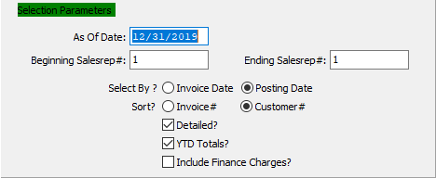

#### As Of Date

For Jobs Closed After - (As of) Enter the as of date.

#### Beginning Sales Rep # / Ending Sales Rep #

Enter the beginning and ending Sales Representative Number to run the Current Period-To-Date Sales report for.

#### Select By (Choice)

To choose the preferred date selection of Invoice Date vs. Posting Date, please make sure the desired option choice bubble is toggled.

#### Sort? (Choice)

To choose the preferred sorting method of Invoice Number vs. Customer Number, please make sure the desired option choice bubble is toggled.

#### Detailed – Toggle Box

To include detailed information for items within the selected parameters, make sure that the Detailed toggle box is checked.

#### YTD Totals? – Toggle Box

To include any Year-to-Date totals from the selected parameters on the report, make sure that the YTD Totals toggle box is checked.

#### Include Finance Charges? – Toggle Box

To include and finance charges within the selected parameters on the report, make sure that the Include Finance Charges toggle box is checked.

### Available and Selected Columns

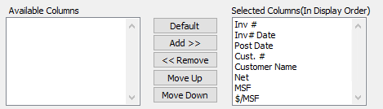

#### Available Columns

The user may choose which columns they wish to have on the report printout. As the user selects their choices, they will appear on the ‘*Selected Columns’* list.

#### Selected Columns (In Display Order)

The columns that the user has chosen from the ‘*Available Columns’* list. The order that these columns are displayed in here is the order in which they will print on the report.

#### Default

Click the ***“Default****”* button to sort the ‘*Selected Columns’* list by the default system parameters.

#### Add >>

Click on the selected item from the ‘*Available Columns’* list to highlight it, then click the ***“Add”*** button to add the selected column to the ‘*Selected Columns’* list.

#### << Remove

Click on the selected item from the ‘*Selected Columns’* list to highlight it, then click the ***“Remove”*** button to remove the selected column to the ‘*Selected Columns’* list.

#### Move Up

Within the ‘*Selected Columns’* list, the user may choose the order they wish the selected columns to print in. In order to change the order of the columns, the user can click on a selection to highlight it. By then clicking the ***“Move Up***” button, the user can change its position on the report.

#### Move Down

Within the ‘*Selected Columns’* list, the user may choose the order they wish the selected columns to print in. In order to change the order of the columns, the user can click on a selection to highlight it. By then clicking the ***“Move Down***” button, the user can change its position on the report.

### Output Destination

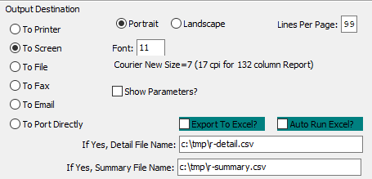

#### Destination Choice

To choose the destination where the document should be printed, please make sure that desired output destination choice bubble is toggled.

#### Layout Choice

To choose the preferred layout of Landscape vs. Portrait, please make sure the desired option choice bubbled is toggled.

#### Lines Per Page

Lines per page on the report when printing.

#### Font

Enter the font number to use with this report (Font 11 is default).

#### Show Parameters? – Toggle Box

To show parameters, make sure that the toggle box is ‘ticked’ with a checkmark.

#### Export to Excel? – Toggle Box

To export the printed file to an excel document, make sure that the Export to Excel toggle box is checked.

#### Auto Run Excel? – Toggle Box

To automatically open the new excel document, make sure that the Auto Run Excel toggle box is checked.

#### If Yes, File Name

If exporting the file to Excel, enter the desired file name.

#### If Yes, Summary File Name

If exporting the file to Excel, enter the desired file name.

# **Billing Detail Sales Journal [HB]**

### Selection Parameters

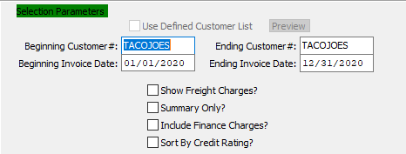

#### Use Defined Customer List – Toggle Box

To use a pre-defined customer list, make sure that this toggle box is checked.

#### Beginning Customer # / Ending Customer #

Enter the beginning and ending Customer Number to run the Billing Detail Sales Journal report for.

#### Beginning Invoice Date / Ending Invoice Date

Enter the beginning and ending Invoice Date to run the Billing Detail Sales Journal report for.

#### Show Freight Charges – Toggle Box

To show any freight charges within the selected parameters, make sure that the Shoe Freight Charges toggle box is checked.

#### Summary Only – Toggle Box

To only print summarized information for the selected parameters, make sure that the Summary Only toggle box is checked.

#### Include Finance Charges? – Toggle Box

To include and finance charges within the selected parameters on the report, make sure that the Include Finance Charges toggle box is checked.

#### Sort by Credit Rating? – Toggle Box

To sort the report by each customer’s credit rating, make sure that the Sort by Credit Rating toggle box is checked.

### Available and Selected Columns

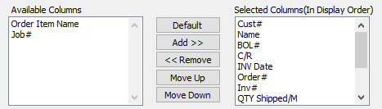

#### Available Columns

The user may choose which columns they wish to have on the report printout. As the user selects their choices, they will appear on the ‘*Selected Columns’* list.

#### Selected Columns (In Display Order)

The columns that the user has chosen from the ‘*Available Columns’* list. The order that these columns are displayed in here is the order in which they will print on the report.

#### Default

Click the ***“Default****”* button to sort the ‘*Selected Columns’* list by the default system parameters.

#### Add >>

Click on the selected item from the ‘*Available Columns’* list to highlight it, then click the ***“Add”*** button to add the selected column to the ‘*Selected Columns’* list.

#### << Remove

Click on the selected item from the ‘*Selected Columns’* list to highlight it, then click the ***“Remove”*** button to remove the selected column to the ‘*Selected Columns’* list.

#### Move Up

Within the ‘*Selected Columns’* list, the user may choose the order they wish the selected columns to print in. In order to change the order of the columns, the user can click on a selection to highlight it. By then clicking the ***“Move Up***” button, the user can change its position on the report.

#### Move Down

Within the ‘*Selected Columns’* list, the user may choose the order they wish the selected columns to print in. In order to change the order of the columns, the user can click on a selection to highlight it. By then clicking the ***“Move Down***” button, the user can change its position on the report.

### Output Destination

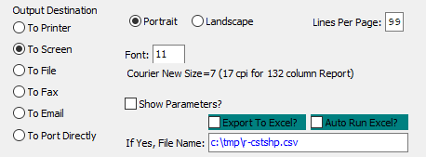

#### Destination Choice

To choose the destination where the document should be printed, please make sure that desired output destination choice bubble is toggled.

#### Layout Choice

To choose the preferred layout of Landscape vs. Portrait, please make sure the desired option choice bubbled is toggled.

#### Lines Per Page

Lines per page on the report when printing.

#### Font

Enter the font number to use with this report (Font 11 is default).

#### Show Parameters? – Toggle Box

To show parameters, make sure that the toggle box is ‘ticked’ with a checkmark.

#### Export to Excel? – Toggle Box

To export the printed file to an excel document, make sure that the Export to Excel toggle box is checked.

#### Auto Run Excel? – Toggle Box

To automatically open the new excel document, make sure that the Auto Run Excel toggle box is checked.

#### If Yes, File Name

If exporting the file to Excel, enter the desired file name.

# **FG Category Product Sales [HF]**

### Selection Parameters

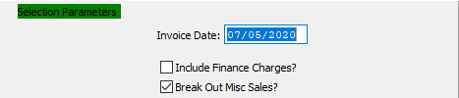

#### Invoice Date

The date the invoice was created which defaults to date in system clock. Format is mm/dd/yy and may be modified.

For releases that are ***"I"*** (Invoice Only), this will default to the date the release was entered. For releases that are ***"S"*** (Ship Only) or ***“B”*** (Both Ship and Invoice), the invoice date will default to the date the Bill of Lading was entered. In any advent, the date may be modified, whereby the aging report will be calculated from the invoice date.

#### Include Finance Charges? – Toggle Box

To include and finance charges within the selected parameters on the report, make sure that the Include Finance Charges toggle box is checked.

#### Break Out Misc. Sales? – Toggle Box

To break out miscellaneous sales numbers from other sales figures within the selected parameters, make sure that this toggle box is checked.

### Available and Selected Columns

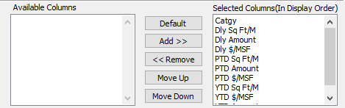

#### Available Columns

The user may choose which columns they wish to have on the report printout. As the user selects their choices, they will appear on the ‘*Selected Columns’* list.

#### Selected Columns (In Display Order)

The columns that the user has chosen from the ‘*Available Columns’* list. The order that these columns are displayed in here is the order in which they will print on the report.

#### Default

Click the ***“Default****”* button to sort the ‘*Selected Columns’* list by the default system parameters.

#### Add >>

Click on the selected item from the ‘*Available Columns’* list to highlight it, then click the ***“Add”*** button to add the selected column to the ‘*Selected Columns’* list.

#### << Remove

Click on the selected item from the ‘*Selected Columns’* list to highlight it, then click the ***“Remove”*** button to remove the selected column to the ‘*Selected Columns’* list.

#### Move Up

Within the ‘*Selected Columns’* list, the user may choose the order they wish the selected columns to print in. In order to change the order of the columns, the user can click on a selection to highlight it. By then clicking the ***“Move Up***” button, the user can change its position on the report.

#### Move Down

Within the ‘*Selected Columns’* list, the user may choose the order they wish the selected columns to print in. In order to change the order of the columns, the user can click on a selection to highlight it. By then clicking the ***“Move Down***” button, the user can change its position on the report.

### Output Destination

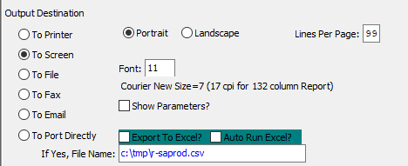

#### Destination Choice

To choose the destination where the document should be printed, please make sure that desired output destination choice bubble is toggled.

#### Layout Choice

To choose the preferred layout of Landscape vs. Portrait, please make sure the desired option choice bubbled is toggled.

#### Show Parameters? – Toggle Box

To show parameters, make sure that the toggle box is ‘ticked’ with a checkmark.

#### Export to Excel? – Toggle Box

To export the printed file to an excel document, make sure that the Export to Excel toggle box is checked.

#### Auto Run Excel? – Toggle Box

To automatically open the new excel document, make sure that the Auto Run Excel toggle box is checked.

# **Totals by Sales Rep DD/MM/YY [HT]**

### Selection Parameters

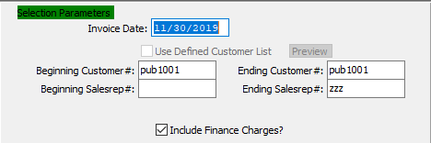

#### Invoice Date

The date the invoice was created which defaults to date in system clock. Format is mm/dd/yy and may be modified.

For releases that are ***"I"*** (Invoice Only), this will default to the date the release was entered. For releases that are ***"S"*** (Ship Only) or ***“B”*** (Both Ship and Invoice), the invoice date will default to the date the Bill of Lading was entered. In any advent, the date may be modified, whereby the aging report will be calculated from the invoice date.

#### Use Defined Customer List – Toggle Box

To use a pre-defined customer list, make sure that this toggle box is checked.

#### Beginning Customer # / Ending Customer #

Enter the beginning and ending Customer Number to run the Total by Sales Representative report for.

#### Beginning Sales Rep # / Ending Sales Rep #

Enter the beginning and ending Sales Representative Number to run the Total by Sales Representative report for.

#### Include Finance Charges? – Toggle Box

To include and finance charges within the selected parameters on the report, make sure that the Include Finance Charges toggle box is checked.

### Available and Selected Columns

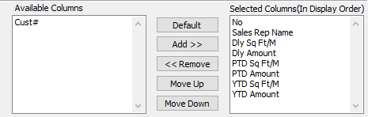

#### Available Columns

The user may choose which columns they wish to have on the report printout. As the user selects their choices, they will appear on the ‘*Selected Columns’* list.

#### Selected Columns (In Display Order)

The columns that the user has chosen from the ‘*Available Columns’* list. The order that these columns are displayed in here is the order in which they will print on the report.

#### Default

Click the ***“Default****”* button to sort the ‘*Selected Columns’* list by the default system parameters.

#### Add >>

Click on the selected item from the ‘*Available Columns’* list to highlight it, then click the ***“Add”*** button to add the selected column to the ‘*Selected Columns’* list.

#### << Remove

Click on the selected item from the ‘*Selected Columns’* list to highlight it, then click the ***“Remove”*** button to remove the selected column to the ‘*Selected Columns’* list.

#### Move Up

Within the ‘*Selected Columns’* list, the user may choose the order they wish the selected columns to print in. In order to change the order of the columns, the user can click on a selection to highlight it. By then clicking the ***“Move Up***” button, the user can change its position on the report.

#### Move Down

Within the ‘*Selected Columns’* list, the user may choose the order they wish the selected columns to print in. In order to change the order of the columns, the user can click on a selection to highlight it. By then clicking the ***“Move Down***” button, the user can change its position on the report.

### Output Destination

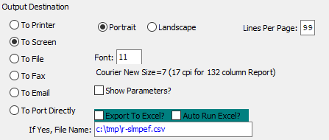

#### Destination Choice

To choose the destination where the document should be printed, please make sure that desired output destination choice bubble is toggled.

#### Layout Choice

To choose the preferred layout of Landscape vs. Portrait, please make sure the desired option choice bubbled is toggled.

#### Lines Per Page

Lines per page on the report when printing.

#### Font

Enter the font number to use with this report (Font 11 is default).

#### Show Parameters? – Toggle Box

To show parameters, make sure that the toggle box is ‘ticked’ with a checkmark.

#### Export to Excel? – Toggle Box

To export the printed file to an excel document, make sure that the Export to Excel toggle box is checked.

#### Auto Run Excel? – Toggle Box

To automatically open the new excel document, make sure that the Auto Run Excel toggle box is checked.

#### If Yes, File Name

If exporting the file to Excel, enter the desired file name.

# **With $/MSF Total by Sales Rep [HW]**

### Selection Parameters

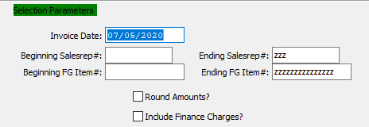

#### Invoice Date

The date the invoice was created which defaults to date in system clock. Format is mm/dd/yy and may be modified.

For releases that are ***"I"*** (Invoice Only), this will default to the date the release was entered. For releases that are ***"S"*** (Ship Only) or ***“B”*** (Both Ship and Invoice), the invoice date will default to the date the Bill of Lading was entered. In any advent, the date may be modified, whereby the aging report will be calculated from the invoice date.

#### Beginning Sales Rep # / Ending Sales Rep #

Enter the beginning and ending Sales Representative Number to run the Total by Sales Representative report for.

#### Beginning FG Item # / Ending FG Item #

Enter the beginning and ending Finished Good Item Number to run the Total by Sales Representative report for.

#### Round Amounts? – Toggle Box

To round all amounts to their nearest dollar, make sure that the Round Amounts toggle box is checked.

#### Include Finance Charges? – Toggle Box

To include and finance charges within the selected parameters on the report, make sure that the Include Finance Charges toggle box is checked.

### Available and Selected Columns

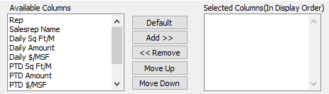

#### Available Columns

The user may choose which columns they wish to have on the report printout. As the user selects their choices, they will appear on the ‘*Selected Columns’* list.

#### Selected Columns (In Display Order)

The columns that the user has chosen from the ‘*Available Columns’* list. The order that these columns are displayed in here is the order in which they will print on the report.

#### Default

Click the ***“Default****”* button to sort the ‘*Selected Columns’* list by the default system parameters.

#### Add >>

Click on the selected item from the ‘*Available Columns’* list to highlight it, then click the ***“Add”*** button to add the selected column to the ‘*Selected Columns’* list.

#### << Remove

Click on the selected item from the ‘*Selected Columns’* list to highlight it, then click the ***“Remove”*** button to remove the selected column to the ‘*Selected Columns’* list.

#### Move Up

Within the ‘*Selected Columns’* list, the user may choose the order they wish the selected columns to print in. In order to change the order of the columns, the user can click on a selection to highlight it. By then clicking the ***“Move Up***” button, the user can change its position on the report.

#### Move Down

Within the ‘*Selected Columns’* list, the user may choose the order they wish the selected columns to print in. In order to change the order of the columns, the user can click on a selection to highlight it. By then clicking the ***“Move Down***” button, the user can change its position on the report.

### Output Destination

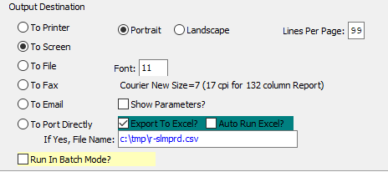

#### Destination Choice

To choose the destination where the document should be printed, please make sure that desired output destination choice bubble is toggled.

#### Layout Choice

To choose the preferred layout of Landscape vs. Portrait, please make sure the desired option choice bubbled is toggled.

#### Lines Per Page

Lines per page on the report when printing.

#### Font

Enter the font number to use with this report (Font 11 is default).

#### Show Parameters? – Toggle Box

To show parameters, make sure that the toggle box is ‘ticked’ with a checkmark.

#### Export to Excel? – Toggle Box

To export the printed file to an excel document, make sure that the Export to Excel toggle box is checked.

#### Auto Run Excel? – Toggle Box

To automatically open the new excel document, make sure that the Auto Run Excel toggle box is checked.

#### If Yes, File Name

If exporting the file to Excel, enter the desired file name.

#### Run in Batch Mode? – Toggle Box

To run the printer in Batch Mode, make sure that this toggle box is checked.

# **Z. Sales by Customer Invoice [HZ]**

### Selection Parameters

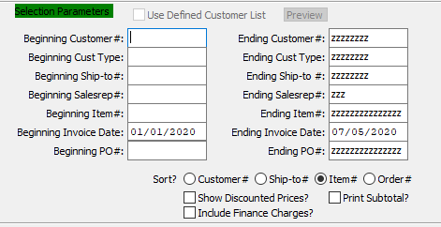

#### Use Defined Customer List – Toggle Box

To use a pre-defined customer list, make sure that this toggle box is checked.

#### Beginning Customer # / Ending Customer #

Enter the beginning and ending Customer Number to run the Sales by Customer Invoice report for.

#### Beginning Customer Type / Ending Customer Type

Enter the beginning and ending Customer Type to run the Sales by Customer Invoice report for.

#### Beginning Ship-To # / Ending Ship-To #

Enter the beginning and ending Ship-To Number to run the Sales by Customer Invoice report for.

#### Beginning Sales Rep # / Ending Sales Rep #

Enter the beginning and ending Sales Representative Number to run the Sales by Customer Invoice report for.

#### Beginning Item # / Ending Item #

Enter the beginning and ending Item Number to run the Sales by Customer Invoice report for.

#### Beginning Invoice Date / Ending Invoice Date

Enter the beginning and ending Invoice Date to run the Sales by Customer Invoice report for.

#### Beginning PO # / Ending PO #

Enter the beginning and ending Purchase Order Number to run the Sales by Customer Invoice report for.

#### Sort? (Choice)

To choose the preferred sorting method, please make sure the desired option choice bubble is toggled.

#### Show Discounted Prices? – Toggle Box

To show any discounted prices within the selected parameters, make sure that the Show Discounted Prices toggle box is checked.

#### Print Subtotal? – Toggle Box

To print a subtotal on the report, make sure that the Print Subtotal toggle box is checked.

#### Include Finance Charges? – Toggle Box

To include and finance charges within the selected parameters on the report, make sure that the Include Finance Charges toggle box is checked.

### Available and Selected Columns

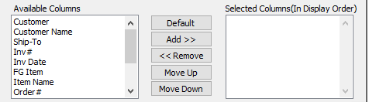

#### Available Columns

The user may choose which columns they wish to have on the report printout. As the user selects their choices, they will appear on the ‘*Selected Columns’* list.

#### Selected Columns (In Display Order)

The columns that the user has chosen from the ‘*Available Columns’* list. The order that these columns are displayed in here is the order in which they will print on the report.

#### Default

Click the ***“Default****”* button to sort the ‘*Selected Columns’* list by the default system parameters.

#### Add >>

Click on the selected item from the ‘*Available Columns’* list to highlight it, then click the ***“Add”*** button to add the selected column to the ‘*Selected Columns’* list.

#### << Remove

Click on the selected item from the ‘*Selected Columns’* list to highlight it, then click the ***“Remove”*** button to remove the selected column to the ‘*Selected Columns’* list.

#### Move Up

Within the ‘*Selected Columns’* list, the user may choose the order they wish the selected columns to print in. In order to change the order of the columns, the user can click on a selection to highlight it. By then clicking the ***“Move Up***” button, the user can change its position on the report.

#### Move Down

Within the ‘*Selected Columns’* list, the user may choose the order they wish the selected columns to print in. In order to change the order of the columns, the user can click on a selection to highlight it. By then clicking the ***“Move Down***” button, the user can change its position on the report.

### Output Destination

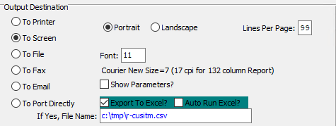

#### Destination Choice

To choose the destination where the document should be printed, please make sure that desired output destination choice bubble is toggled.

#### Layout Choice

To choose the preferred layout of Landscape vs. Portrait, please make sure the desired option choice bubbled is toggled.

#### Lines Per Page

Lines per page on the report when printing.

#### Font

Enter the font number to use with this report (Font 11 is default).

#### Show Parameters? – Toggle Box

To show parameters, make sure that the toggle box is ‘ticked’ with a checkmark.

#### Export to Excel? – Toggle Box

To export the printed file to an excel document, make sure that the Export to Excel toggle box is checked.

#### Auto Run Excel? – Toggle Box

To automatically open the new excel document, make sure that the Auto Run Excel toggle box is checked.

#### If Yes, File Name

If exporting the file to Excel, enter the desired file name.

# **Value / Profit by Item [HV]**

### Selection Parameters

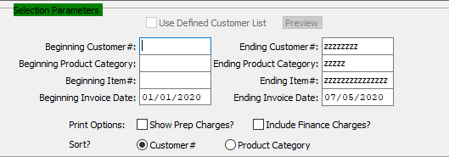

#### Use Defined Customer List – Toggle Box

To use a pre-defined customer list, make sure that this toggle box is checked.

#### Beginning Customer # / Ending Customer #

Enter the beginning and ending Customer Number to run the Value/Profit by Item report for.

#### Beginning Product Category / Ending Product Category

Enter the beginning and ending Product Category to run the Value/Profit by Item report for.

#### Beginning Item # / Ending Item #

Enter the beginning and ending Item Number to run the Value/Profit by Item report for.

#### Beginning Invoice Date / Ending Invoice Date

Enter the beginning and ending Invoice Date to run the Value/Profit by Item report for.

#### Show Prep Charges? – Toggle Box

To show any preparation charges within the selected parameters, make sure that the Show Prep Charges toggle box is checked.

#### Include Finance Charges? – Toggle Box

To include and finance charges within the selected parameters on the report, make sure that the Include Finance Charges toggle box is checked.

#### Sort? (Choice)

To choose the preferred sorting method of Customer Number vs. Product Category, please make sure the desired option choice bubble is toggled.

### Available and Selected Columns

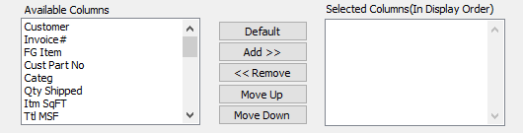

#### Available Columns

The user may choose which columns they wish to have on the report printout. As the user selects their choices, they will appear on the ‘*Selected Columns’* list.

#### Selected Columns (In Display Order)

The columns that the user has chosen from the ‘*Available Columns’* list. The order that these columns are displayed in here is the order in which they will print on the report.

#### Default

Click the ***“Default****”* button to sort the ‘*Selected Columns’* list by the default system parameters.

#### Add >>

Click on the selected item from the ‘*Available Columns’* list to highlight it, then click the ***“Add”*** button to add the selected column to the ‘*Selected Columns’* list.

#### << Remove

Click on the selected item from the ‘*Selected Columns’* list to highlight it, then click the ***“Remove”*** button to remove the selected column to the ‘*Selected Columns’* list.

#### Move Up

Within the ‘*Selected Columns’* list, the user may choose the order they wish the selected columns to print in. In order to change the order of the columns, the user can click on a selection to highlight it. By then clicking the ***“Move Up***” button, the user can change its position on the report.

#### Move Down

Within the ‘*Selected Columns’* list, the user may choose the order they wish the selected columns to print in. In order to change the order of the columns, the user can click on a selection to highlight it. By then clicking the ***“Move Down***” button, the user can change its position on the report.

### Output Destination

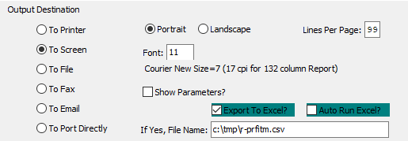

#### Destination Choice

To choose the destination where the document should be printed, please make sure that desired output destination choice bubble is toggled.

#### Layout Choice

To choose the preferred layout of Landscape vs. Portrait, please make sure the desired option choice bubbled is toggled.

#### Lines Per Page

Lines per page on the report when printing.

#### Font

Enter the font number to use with this report (Font 11 is default).

#### Show Parameters? – Toggle Box

To show parameters, make sure that the toggle box is ‘ticked’ with a checkmark.

#### Export to Excel? – Toggle Box

To export the printed file to an excel document, make sure that the Export to Excel toggle box is checked.

#### Auto Run Excel? – Toggle Box

To automatically open the new excel document, make sure that the Auto Run Excel toggle box is checked.

#### If Yes, File Name

If exporting the file to Excel, enter the desired file name.

# **Yearly Sales Volume [HY]**

### Selection Parameters

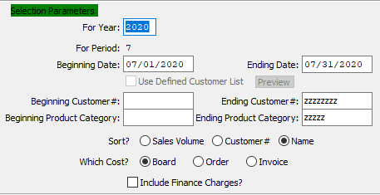

#### For Year

Enter a year to run the report for.

#### For Period

This is the period number of the transaction date relative to the fiscal year.

#### Beginning Date / Ending Date

Enter the beginning and ending Date to run the Yearly Sales Volume report for.

#### Use Defined Customer List – Toggle Box

To use a pre-defined customer list, make sure that this toggle box is checked.

#### Beginning Customer # / Ending Customer #

Enter the beginning and ending Customer Number to run the Yearly Sales Volume report for.

#### Beginning Product Category / Ending Product Category

Enter the beginning and ending Product Category to run the Yearly Sales Volume report for.

#### Sort? (Choice)

To choose the preferred soring method of Sales Volume vs. Customer Number vs. Customer Name, please make sure the desired option choice bubble is toggled.

#### Which Cost? (Choice)

To choose the preferred cost option of Board Cost vs. Order Total vs. Invoice Total, please make sure the desired option choice bubble is toggled.

#### Include Finance Charges? – Toggle Box

To include and finance charges within the selected parameters on the report, make sure that the Include Finance Charges toggle box is checked.

### Available and Selected Columns

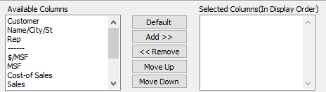

#### Available Columns

The user may choose which columns they wish to have on the report printout. As the user selects their choices, they will appear on the ‘*Selected Columns’* list.

#### Selected Columns (In Display Order)

The columns that the user has chosen from the ‘*Available Columns’* list. The order that these columns are displayed in here is the order in which they will print on the report.

#### Default

Click the ***“Default****”* button to sort the ‘*Selected Columns’* list by the default system parameters.

#### Add >>

Click on the selected item from the ‘*Available Columns’* list to highlight it, then click the ***“Add”*** button to add the selected column to the ‘*Selected Columns’* list.

#### << Remove

Click on the selected item from the ‘*Selected Columns’* list to highlight it, then click the ***“Remove”*** button to remove the selected column to the ‘*Selected Columns’* list.

#### Move Up

Within the ‘*Selected Columns’* list, the user may choose the order they wish the selected columns to print in. In order to change the order of the columns, the user can click on a selection to highlight it. By then clicking the ***“Move Up***” button, the user can change its position on the report.

#### Move Down

Within the ‘*Selected Columns’* list, the user may choose the order they wish the selected columns to print in. In order to change the order of the columns, the user can click on a selection to highlight it. By then clicking the ***“Move Down***” button, the user can change its position on the report.

### Output Destination

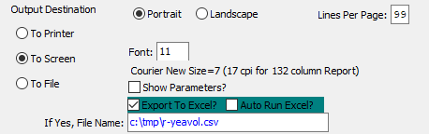

#### Destination Choice

To choose the destination where the document should be printed, please make sure that desired output destination choice bubble is toggled.

#### Layout Choice

To choose the preferred layout of Landscape vs. Portrait, please make sure the desired option choice bubbled is toggled.

#### Lines Per Page

Lines per page on the report when printing.

#### Font

Enter the font number to use with this report (Font 11 is default).

#### Show Parameters? – Toggle Box

To show parameters, make sure that the toggle box is ‘ticked’ with a checkmark.

#### Export to Excel? – Toggle Box

To export the printed file to an excel document, make sure that the Export to Excel toggle box is checked.

#### Auto Run Excel? – Toggle Box

To automatically open the new excel document, make sure that the Auto Run Excel toggle box is checked.

#### If Yes, File Name

If exporting the file to Excel, enter the desired file name.

# **Last Year vs. This Year [HL]**

### Selection Parameters

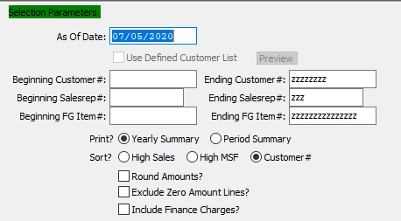

#### As Of Date

For Jobs Closed After - (As of) Enter the as of date.

#### Use Defined Customer List – Toggle Box

To use a pre-defined customer list, make sure that this toggle box is checked.

#### Beginning Customer # / Ending Customer #

Enter the beginning and ending Customer Number to run the Last Year vs. This Year report for.

#### Beginning Sales Rep # / Ending Sales Rep #

Enter the beginning and ending Sales Representative Number to run the Last Year vs. This Year report for.

#### Beginning FG Item # / Ending FG Item #

Enter the beginning and ending Finished Good Item Number to run the Last Year vs. This Year report for.

#### Print? (Choice)

To choose the preferred printing summary of Yearly vs. Period, please make sure the desired option choice bubble is toggled.

#### Sort? (Choice)

To choose the preferred sorting method of High Sales Numbers vs. High MSF Numbers vs. Customer Numbers, please make sure the desired option choice bubble is toggled.

#### Round Amounts? – Toggle Box

To round all amounts to their nearest dollar, make sure that the Round Amounts toggle box is checked.

#### Exclude Zero Amount Lines? – Toggle Box

To exclude any lines within the selected parameters that have a zero inventory or sales amount, make sure that this toggle box is checked.

#### Include Finance Amount Charges? – Toggle Box

To include and finance charges within the selected parameters on the report, make sure that the Include Finance Amount Charges toggle box is checked.

### Available and Selected Columns

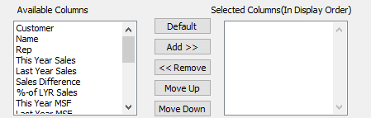

#### Available Columns

The user may choose which columns they wish to have on the report printout. As the user selects their choices, they will appear on the ‘*Selected Columns’* list.

#### Selected Columns (In Display Order)

The columns that the user has chosen from the ‘*Available Columns’* list. The order that these columns are displayed in here is the order in which they will print on the report.

#### Default

Click the ***“Default****”* button to sort the ‘*Selected Columns’* list by the default system parameters.

#### Add >>

Click on the selected item from the ‘*Available Columns’* list to highlight it, then click the ***“Add”*** button to add the selected column to the ‘*Selected Columns’* list.

#### << Remove

Click on the selected item from the ‘*Selected Columns’* list to highlight it, then click the ***“Remove”*** button to remove the selected column to the ‘*Selected Columns’* list.

#### Move Up

Within the ‘*Selected Columns’* list, the user may choose the order they wish the selected columns to print in. In order to change the order of the columns, the user can click on a selection to highlight it. By then clicking the ***“Move Up***” button, the user can change its position on the report.

#### Move Down

Within the ‘*Selected Columns’* list, the user may choose the order they wish the selected columns to print in. In order to change the order of the columns, the user can click on a selection to highlight it. By then clicking the ***“Move Down***” button, the user can change its position on the report.

### Output Destination

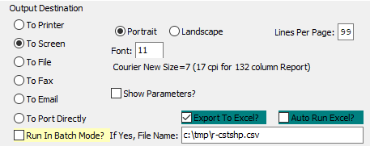

#### Destination Choice

To choose the destination where the document should be printed, please make sure that desired output destination choice bubble is toggled.

#### Layout Choice

To choose the preferred layout of Landscape vs. Portrait, please make sure the desired option choice bubbled is toggled.

#### Lines Per Page

Lines per page on the report when printing.

#### Font

Enter the font number to use with this report (Font 11 is default).

#### Show Parameters? – Toggle Box

To show parameters, make sure that the toggle box is ‘ticked’ with a checkmark.

#### Export to Excel? – Toggle Box

To export the printed file to an excel document, make sure that the Export to Excel toggle box is checked.

#### Auto Run Excel? – Toggle Box

To automatically open the new excel document, make sure that the Auto Run Excel toggle box is checked.

#### If Yes, File Name

If exporting the file to Excel, enter the desired file name.

#### Run in Batch Mode? – Toggle Box

To run the printer in Batch Mode, make sure that this toggle box is checked.

# **Sales vs. Budget [HS]**

### Selection Parameters

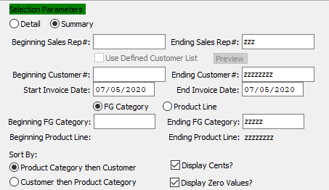

#### Print Options (Choice)

To choose the preferred printing option of Detailed Information vs. Summarized Information, please make sure the desired option choice bubble is toggled.

#### Beginning Sales Rep # / Ending Sales Rep #

Enter the beginning and ending Sales Representative Number to run the Sales vs. Budget report for.

#### Use Defined Customer List – Toggle Box

To use a pre-defined customer list, make sure that this toggle box is checked.

#### Beginning Customer # / Ending Customer #

Enter the beginning and ending Customer Number to run the Sales vs. Budget report for.

#### Beginning Invoice Date / Ending Invoice Date

Enter the beginning and ending Invoice Date to run the Sales vs. Budget report for.

#### Type (Choice)

To choose the preferred inventory type of Finished Good Category vs. Product Line, please make sure the desired option choice bubble is toggled.

#### Beginning FG Category / Ending FG Category

Enter the beginning and ending Finished Good Category to run the Sales vs. Budget report for.

#### Sort By (Choice)

To choose the preferred sorting method of Product Category then Customer vs. Customer then Product Category, please make sure the desired option choice bubble is toggled.

#### Display Cents? – Toggle Box

To display cents for all sales numbers within the report parameters, make sure that the Display Cents toggle box is checked.

#### Display Zero Values? – Toggle Box

To include any selected parameters that have no value in the report, make sure that the Display Zero Values toggle box is checked.

### Available and Selected Columns

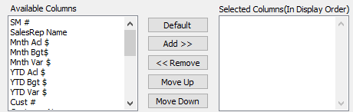

#### Available Columns

The user may choose which columns they wish to have on the report printout. As the user selects their choices, they will appear on the ‘*Selected Columns’* list.

#### Selected Columns (In Display Order)

The columns that the user has chosen from the ‘*Available Columns’* list. The order that these columns are displayed in here is the order in which they will print on the report.

#### Default

Click the ***“Default****”* button to sort the ‘*Selected Columns’* list by the default system parameters.

#### Add >>

Click on the selected item from the ‘*Available Columns’* list to highlight it, then click the ***“Add”*** button to add the selected column to the ‘*Selected Columns’* list.

#### << Remove

Click on the selected item from the ‘*Selected Columns’* list to highlight it, then click the ***“Remove”*** button to remove the selected column to the ‘*Selected Columns’* list.

#### Move Up

Within the ‘*Selected Columns’* list, the user may choose the order they wish the selected columns to print in. In order to change the order of the columns, the user can click on a selection to highlight it. By then clicking the ***“Move Up***” button, the user can change its position on the report.

#### Move Down

Within the ‘*Selected Columns’* list, the user may choose the order they wish the selected columns to print in. In order to change the order of the columns, the user can click on a selection to highlight it. By then clicking the ***“Move Down***” button, the user can change its position on the report.

### Output Destination

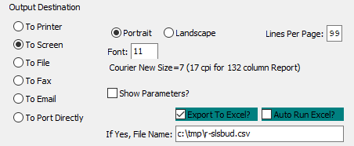

#### Destination Choice

To choose the destination where the document should be printed, please make sure that desired output destination choice bubble is toggled.

#### Layout Choice

To choose the preferred layout of Landscape vs. Portrait, please make sure the desired option choice bubbled is toggled.

#### Lines Per Page

Lines per page on the report when printing.

#### Font

Enter the font number to use with this report (Font 11 is default).

#### Show Parameters? – Toggle Box

To show parameters, make sure that the toggle box is ‘ticked’ with a checkmark.

#### Export to Excel? – Toggle Box

To export the printed file to an excel document, make sure that the Export to Excel toggle box is checked.

#### Auto Run Excel? – Toggle Box

To automatically open the new excel document, make sure that the Auto Run Excel toggle box is checked.

#### If Yes, File Name

If exporting the file to Excel, enter the desired file name.

# **Management Highlights [HM]**

## Management Highlights Summary [HM1]

### Selection Parameters

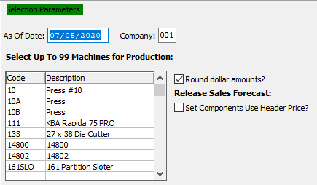

#### As Of Date

For Jobs Closed After - (As of) Enter the as of date.

#### Company

Enter a company number to run the report for.

#### Round Dollar Amounts? – Toggle Box

To round all dollar amount within the selected parameters, make sure that the Round Dollar Amounts toggle box is checked.

Please Note: This will round the dollar amounts up or down depending on their amount. For example, $1.32 will round down to $1; while $1.99 will round up to $2.

#### Set Components Use Header Price? – Toggle Box

To have individual set components use their head price on the report, make sure that this toggle box is checked.

### Select Machines

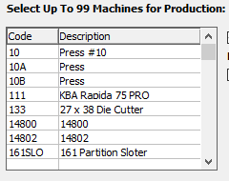

The user may choose multiple Machines for Production from this list by using the ***“Control – Click”*** method. A selected Machine will by highlighted within the list, and only highlighted Machines will be used by the system.

### Select Companies

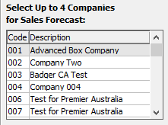

The user may choose multiple Companies fir Sales Forecast from this list by using the ***“Control – Click”*** method. A selected Company will by highlighted within the list, and only highlighted Companies will be used by the system.

### Select A/R Accounts

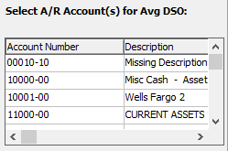

The user may choose multiple Accounts Receivable Account for Average DSO from this list by using the ***“Control – Click”*** method. A selected Account will by highlighted within the list, and only highlighted Accounts will be used by the system.

## Invoice Highlights [HM2]

Select any date to review that day’s invoiced statistics. View in either summery or detail.

### Selection Parameters

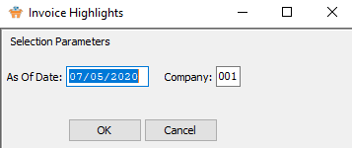

#### As of Date

For Jobs Closed After - (As of) Enter the as of date.

#### Company

Enter a company number to run the report for.

## Booking Highlights [HM3]

Select any date to review the order bookings in summary or detail.

### Selection Parameters

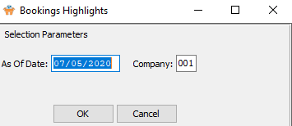

#### As of Date

For Jobs Closed After - (As of) Enter the as of date.

#### Company

Enter a company number to run the report for.

## Sales Rep Highlights [HM4]

Select any date to review the sales management highlights.

### Selection Parameters

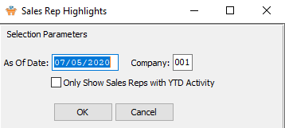

#### As of Date

For Jobs Closed After - (As of) Enter the as of date.

#### Company

Enter a company number to run the report for.

#### Only Show Sales Reps with YTD Activity – Toggle Box

To only show sales representatives with current year-to-date activity within their records, make sure that this toggle box is checked.

## Production Highlights [HM5]

The Management Dashboard allows selecting a variety of machines to show the production statistics for that day.

### Selection Parameters

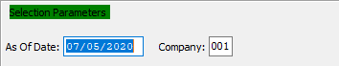

#### As of Date

For Jobs Closed After - (As of) Enter the as of date.

#### Company

Enter a company number to run the report for.

### Select Machines

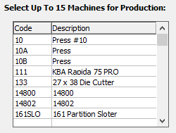

The user may choose multiple Machines for Production from this list by using the ***“Control – Click”*** method. A selected Machine will by highlighted within the list, and only highlighted Machines will be used by the system.

## Management Dashboard [HM6]

### Screen-Specific Icons

|  |  |  |
| --- | --- | --- |
|  | Save |  |
|  | Web Browser | Export the Machine Order parameters to a web browser doc. |
|  | Excel CSV | Export the Machine Order parameters to an Excel CSV document. |
|  | Excel XLS | Export the Machine Order parameters to an Excel XLS document. |
|  | Word DocX | Export the Machine Order parameters to a Word document. |
|  | PDF | Export the Machine Order parameters to a PDF document. |
|  | HTML | Export the Machine Order parameters to an HTML document. |
|  | Print | Print the Machine Order parameters to the default printer. |
|  | Jasper Viewer | View the Machine Order parameters in the Jasper Viewer. |
|  | Tasks | Run the machine Order jasper files. |

### Parameters

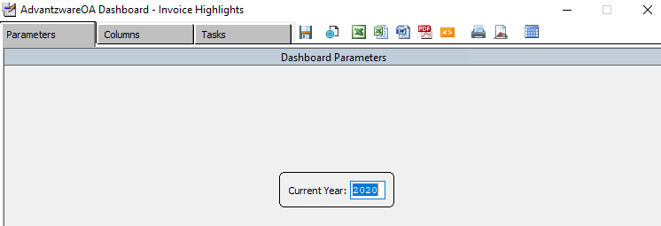

#### Current Year

This field defaults to the current system year. However, this may be modified by the user.

### Columns

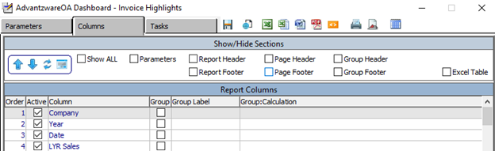

The user should choose all of their desired columns for their parameters.

### Tasks

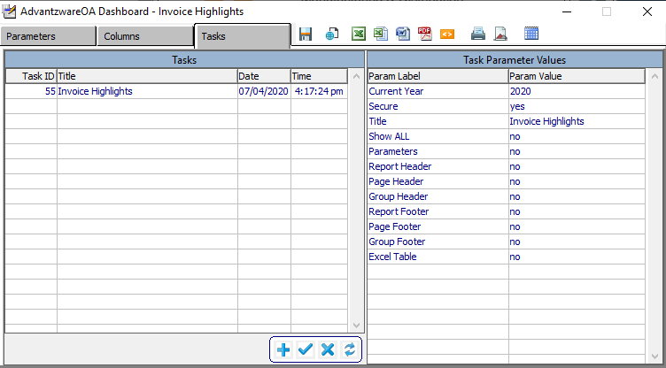

#### ADD

Click the ***“Blue + Icon”*** button at the bottom of the page to add a new task.

#### SAVE

Click the ***“Blue Check Mark Icon”*** button at the bottom of the page to save parameter values to the task ID.

#### DELETE

Click the ***“Blue X Icon”*** button at the bottom of the page to delete the selected task.

#### APPLY

Click the ***“Blue Refresh Icon”*** button at the bottom of the page to apply task values to the parameter values.

# **Reports Continued… [HR]**

## High Sales Tracking [HR1]

### Selection Parameters

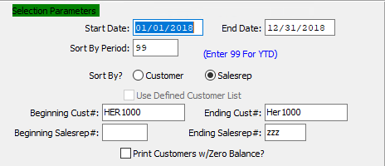

#### Start Date / End Date

Enter the beginning and ending Date to run the report for.

#### Sort by Period

This is the period number of the transaction date relative to the fiscal year.

#### Sort By? (Choice)

To choose the preferred sorting method of Customer Number vs. Sales Representative Number, please make sure the desired option choice bubble is toggled.

#### Use Defined Customer List – Toggle Box

To use a pre-defined customer list, make sure that this toggle box is checked.

#### Beginning Customer # / Ending Customer #

Enter the beginning and ending Customer Number to run the High Sales Tracking report for.

#### Beginning Sales Rep # / Ending Sales Rep #

Enter the beginning and ending Sales Representative Number to run the High Sales Tracking report for.

#### Print Customers w/ Zero Balance – Toggle Box

To include any customers that have zero sales balances in their records within the selected parameters, make sure that this toggle box is checked.

### Available and Selected Columns

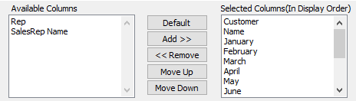

#### Available Columns

The user may choose which columns they wish to have on the report printout. As the user selects their choices, they will appear on the ‘*Selected Columns’* list.

#### Selected Columns (In Display Order)

The columns that the user has chosen from the ‘*Available Columns’* list. The order that these columns are displayed in here is the order in which they will print on the report.

#### Default

Click the ***“Default****”* button to sort the ‘*Selected Columns’* list by the default system parameters.

#### Add >>

Click on the selected item from the ‘*Available Columns’* list to highlight it, then click the ***“Add”*** button to add the selected column to the ‘*Selected Columns’* list.

#### << Remove

Click on the selected item from the ‘*Selected Columns’* list to highlight it, then click the ***“Remove”*** button to remove the selected column to the ‘*Selected Columns’* list.

#### Move Up

Within the ‘*Selected Columns’* list, the user may choose the order they wish the selected columns to print in. In order to change the order of the columns, the user can click on a selection to highlight it. By then clicking the ***“Move Up***” button, the user can change its position on the report.

#### Move Down

Within the ‘*Selected Columns’* list, the user may choose the order they wish the selected columns to print in. In order to change the order of the columns, the user can click on a selection to highlight it. By then clicking the ***“Move Down***” button, the user can change its position on the report.

### Output Destination

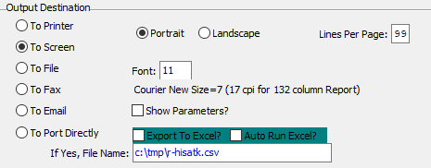

#### Destination Choice

To choose the destination where the document should be printed, please make sure that desired output destination choice bubble is toggled.

#### Layout Choice

To choose the preferred layout of Landscape vs. Portrait, please make sure the desired option choice bubbled is toggled.

#### Lines Per Page

Lines per page on the report when printing.

#### Font

Enter the font number to use with this report (Font 11 is default).

#### Show Parameters? – Toggle Box

To show parameters, make sure that the toggle box is ‘ticked’ with a checkmark.

#### Export to Excel? – Toggle Box

To export the printed file to an excel document, make sure that the Export to Excel toggle box is checked.

#### Auto Run Excel? – Toggle Box

To automatically open the new excel document, make sure that the Auto Run Excel toggle box is checked.

#### If Yes, File Name

If exporting the file to Excel, enter the desired file name.

## High Sales by Date Ranges [HR2]

### Selection Parameters

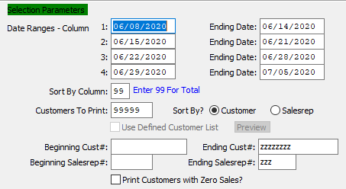

#### Date Ranges: Beginning Date / Ending Date: Columns 1-4

The user may enter up to four separate date ranges to run the report for. Each of these date ranges will print to their own column on the report.

#### Sort by Column

Choose a number between 1 and 4 to sort the report for. Alternatively, enter 99 to sort by the total.

#### Customers to Print

Enter a selection of customers to print the report for. Each customer should be separated by a comma. Alternatively, leave this field as the default 99999 to use all customers.

#### Sort By? (Choice)

To choose the preferred sorting method of Customer Number vs. Sales Representative Number, please make sure the desired option choice bubble is toggled.

#### Use Defined Customer List – Toggle Box

To use a pre-defined customer list, make sure that this toggle box is checked.

#### Beginning Customer # / Ending Customer #

Enter the beginning and ending Customer Number to run the High Sales by Date Range report for.

#### Beginning Sales Rep # / Ending Sales Rep #

Enter the beginning and ending Sales Representative Number to run the High Sales by Date Range report for.

#### Print Customers with Zero Sales? – Toggle Box

To include any customers that have zero sales in their records within the selected parameters, make sure that this toggle box is checked.

### Available and Selected Columns

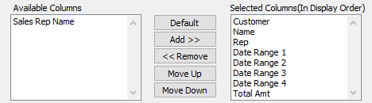

#### Available Columns

The user may choose which columns they wish to have on the report printout. As the user selects their choices, they will appear on the ‘*Selected Columns’* list.

#### Selected Columns (In Display Order)

The columns that the user has chosen from the ‘*Available Columns’* list. The order that these columns are displayed in here is the order in which they will print on the report.

#### Default

Click the ***“Default****”* button to sort the ‘*Selected Columns’* list by the default system parameters.

#### Add >>

Click on the selected item from the ‘*Available Columns’* list to highlight it, then click the ***“Add”*** button to add the selected column to the ‘*Selected Columns’* list.

#### << Remove

Click on the selected item from the ‘*Selected Columns’* list to highlight it, then click the ***“Remove”*** button to remove the selected column to the ‘*Selected Columns’* list.

#### Move Up

Within the ‘*Selected Columns’* list, the user may choose the order they wish the selected columns to print in. In order to change the order of the columns, the user can click on a selection to highlight it. By then clicking the ***“Move Up***” button, the user can change its position on the report.

#### Move Down

Within the ‘*Selected Columns’* list, the user may choose the order they wish the selected columns to print in. In order to change the order of the columns, the user can click on a selection to highlight it. By then clicking the ***“Move Down***” button, the user can change its position on the report.

### Output Destination

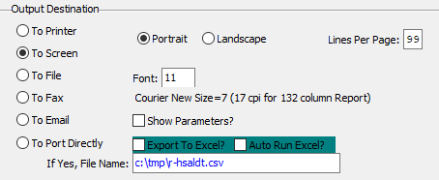

#### Destination Choice

To choose the destination where the document should be printed, please make sure that desired output destination choice bubble is toggled.

#### Layout Choice

To choose the preferred layout of Landscape vs. Portrait, please make sure the desired option choice bubbled is toggled.

#### Lines Per Page

Lines per page on the report when printing.

#### Font

Enter the font number to use with this report (Font 11 is default).

#### Show Parameters? – Toggle Box

To show parameters, make sure that the toggle box is ‘ticked’ with a checkmark.

#### Export to Excel? – Toggle Box

To export the printed file to an excel document, make sure that the Export to Excel toggle box is checked.

#### Auto Run Excel? – Toggle Box

To automatically open the new excel document, make sure that the Auto Run Excel toggle box is checked.

#### If Yes, File Name

If exporting the file to Excel, enter the desired file name.

## Profit by Invoice [HR3]

### Selection Parameters

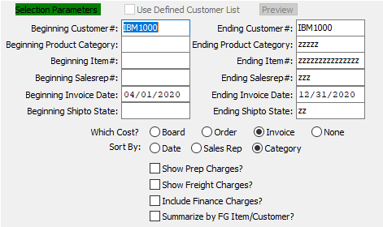

#### Use Defined Customer List – Toggle Box

To use a pre-defined customer list, make sure that this toggle box is checked.

#### Beginning Customer # / Ending Customer #

Enter the beginning and ending Customer Number to run the Profit by Invoice report for.

#### Beginning Product Category / Ending Product Category

Enter the beginning and ending Product Category to run the Profit by Invoice report for.

#### Beginning Item # / Ending Item #

Enter the beginning and ending Item Number to run the Profit by Invoice report for.

#### Beginning Sales Rep # / Ending Sales Rep #

Enter the beginning and ending Sales Representative Number to run the Profit by Invoice report for.

#### Beginning Invoice Date / Ending Invoice Date

Enter the beginning and ending Invoice Date to run the Profit by Invoice report for.

#### Beginning Ship-To Date / Ending Ship-To State

Enter the beginning and ending Ship-To State to run the Profit by Invoice report for.

#### Which Cost? (Choice)

To choose the preferred cost option of Board Cost vs. Order Total vs. Invoice Total (Or None), please make sure the desired option choice bubble is toggled.

#### Sort By (Choice)

To choose the preferred sorting method of Date vs. Sales Representative vs. Category, please make sure the desired option choice bubble is toggled.

#### Show Prep Charges? – Toggle Box

To show any preparation charges within the selected parameters on the report, make sure that the Show Prep Charges toggle box is checked.

#### Show Freight Charges? – Toggle Box

To show any freight charges within the selected parameters on the report, make sure that the Show Freight Charges toggle box is checked.

#### Include Finance Charges? – Toggle Box

To include and finance charges within the selected parameters on the report, make sure that the Include Finance Charges toggle box is checked.

#### Summarize by FG Item/Customer? – Toggle Box

To summarize the report by Finished Good item, and the by customer number, make sure that this toggle box is checked.

### Available and Selected Columns

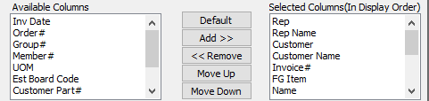

#### Available Columns

The user may choose which columns they wish to have on the report printout. As the user selects their choices, they will appear on the ‘*Selected Columns’* list.

#### Selected Columns (In Display Order)

The columns that the user has chosen from the ‘*Available Columns’* list. The order that these columns are displayed in here is the order in which they will print on the report.

#### Default

Click the ***“Default****”* button to sort the ‘*Selected Columns’* list by the default system parameters.

#### Add >>

Click on the selected item from the ‘*Available Columns’* list to highlight it, then click the ***“Add”*** button to add the selected column to the ‘*Selected Columns’* list.

#### << Remove

Click on the selected item from the ‘*Selected Columns’* list to highlight it, then click the ***“Remove”*** button to remove the selected column to the ‘*Selected Columns’* list.

#### Move Up

Within the ‘*Selected Columns’* list, the user may choose the order they wish the selected columns to print in. In order to change the order of the columns, the user can click on a selection to highlight it. By then clicking the ***“Move Up***” button, the user can change its position on the report.

#### Move Down

Within the ‘*Selected Columns’* list, the user may choose the order they wish the selected columns to print in. In order to change the order of the columns, the user can click on a selection to highlight it. By then clicking the ***“Move Down***” button, the user can change its position on the report.

### Output Destination

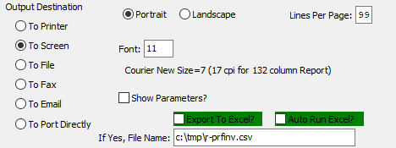

#### Destination Choice

To choose the destination where the document should be printed, please make sure that desired output destination choice bubble is toggled.

#### Layout Choice

To choose the preferred layout of Landscape vs. Portrait, please make sure the desired option choice bubbled is toggled.

#### Lines Per Page

Lines per page on the report when printing.

#### Font

Enter the font number to use with this report (Font 11 is default).

#### Show Parameters? – Toggle Box

To show parameters, make sure that the toggle box is ‘ticked’ with a checkmark.

#### Export to Excel? – Toggle Box

To export the printed file to an excel document, make sure that the Export to Excel toggle box is checked.

#### Auto Run Excel? – Toggle Box

To automatically open the new excel document, make sure that the Auto Run Excel toggle box is checked.

#### If Yes, File Name

If exporting the file to Excel, enter the desired file name.

## Profit by Product Category/Sales Rep [HR4]

### Selection Parameters

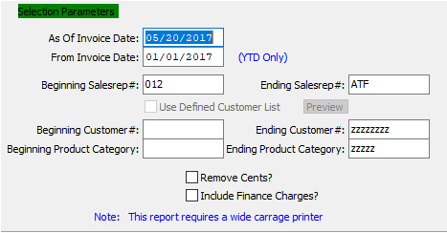

#### As of Invoice Date

For Jobs Closed After - (As of) Enter the as of date.

#### From Invoice Date

The date the invoice was created which defaults to date in system clock. Format is mm/dd/yy and may be modified.

For releases that are ***"I"*** (Invoice Only), this will default to the date the release was entered. For releases that are ***"S"*** (Ship Only) or ***“B”*** (Both Ship and Invoice), the invoice date will default to the date the Bill of Lading was entered. In any advent, the date may be modified, whereby the aging report will be calculated from the invoice date.

#### Beginning Sales Rep # / Ending Sales Rep #

Enter the beginning and ending Sales Representative Number to run the Profit by Product Category or Sales Representative report for.

#### Use Defined Customer List – Toggle Box

To use a pre-defined customer list, make sure that this toggle box is checked.

#### Beginning Customer # / Ending Customer #

Enter the beginning and ending Customer Number to run the Profit by Product Category or Sales Representative report for.

#### Beginning Product Category / Ending Product Category

Enter the beginning and ending Product Category to run the Profit by Product Category or Sales Representative report for.

#### Remove Cents? – Toggle Box

To remove the cents from any sales numbers, make sure that the Remove Cents toggle box is checked.

Please Note: This will not ‘round’ the cents numbers to the nearest dollar amount, it will simply remove them from the report. For example, $1.99 will show on the report as $1, not rounded to $2.

#### Include Finance Charges? – Toggle Box

To include and finance charges within the selected parameters on the report, make sure that the Include Finance Charges toggle box is checked.

### Available and Selected Columns

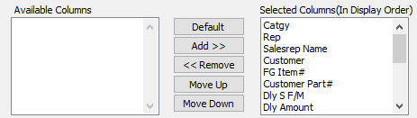

#### Available Columns

The user may choose which columns they wish to have on the report printout. As the user selects their choices, they will appear on the ‘*Selected Columns’* list.

#### Selected Columns (In Display Order)

The columns that the user has chosen from the ‘*Available Columns’* list. The order that these columns are displayed in here is the order in which they will print on the report.

#### Default

Click the ***“Default****”* button to sort the ‘*Selected Columns’* list by the default system parameters.

#### Add >>

Click on the selected item from the ‘*Available Columns’* list to highlight it, then click the ***“Add”*** button to add the selected column to the ‘*Selected Columns’* list.

#### << Remove

Click on the selected item from the ‘*Selected Columns’* list to highlight it, then click the ***“Remove”*** button to remove the selected column to the ‘*Selected Columns’* list.

#### Move Up

Within the ‘*Selected Columns’* list, the user may choose the order they wish the selected columns to print in. In order to change the order of the columns, the user can click on a selection to highlight it. By then clicking the ***“Move Up***” button, the user can change its position on the report.

#### Move Down

Within the ‘*Selected Columns’* list, the user may choose the order they wish the selected columns to print in. In order to change the order of the columns, the user can click on a selection to highlight it. By then clicking the ***“Move Down***” button, the user can change its position on the report.

### Output Destination

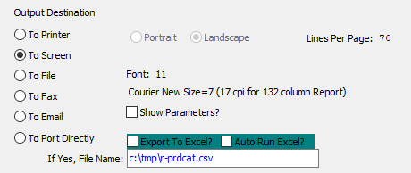

#### Destination Choice

To choose the destination where the document should be printed, please make sure that desired output destination choice bubble is toggled.

#### Layout Choice

To choose the preferred layout of Landscape vs. Portrait, please make sure the desired option choice bubbled is toggled.

#### Lines Per Page

Lines per page on the report when printing.

#### Font

Enter the font number to use with this report (Font 11 is default).

#### Show Parameters? – Toggle Box

To show parameters, make sure that the toggle box is ‘ticked’ with a checkmark.

#### Export to Excel? – Toggle Box

To export the printed file to an excel document, make sure that the Export to Excel toggle box is checked.

#### Auto Run Excel? – Toggle Box

To automatically open the new excel document, make sure that the Auto Run Excel toggle box is checked.

#### If Yes, File Name

If exporting the file to Excel, enter the desired file name.

## Sales by Item / Customer / Shipping Carrier [HR5]

### Selection Parameters

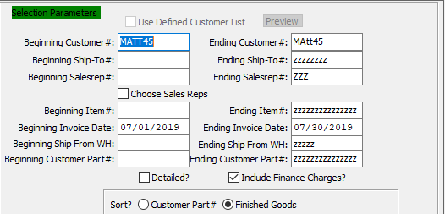

#### Use Defined Customer List – Toggle Box

To use a pre-defined customer list, make sure that this toggle box is checked.

#### Beginning Customer # / Ending Customer #

Enter the beginning and ending Customer Number to run the Sales report for.

#### Beginning Ship-To # / Ending Ship-To #

Enter the beginning and ending Ship-To Number to run the Sales report for.

#### Beginning Sales Rep # / Ending Sales Rep #

Enter the beginning and ending Sales Representative Number to run the Sales report for.

#### Choose Sales Reps – Toggle Box

To choose individual sales representatives for the report, make sure that the Choose Sales Reps toggle box is checked.

#### Beginning Item # / Ending Item #

Enter the beginning and ending Item Number to run the Sales report for.

#### Beginning Invoice Date / Ending Invoice Date

Enter the beginning and ending Invoice Date to run the Sales report for.

#### Beginning Ship From WH / Ending Ship From WH

Enter the beginning and ending Ship From Warehouse to run the Sales report for.

#### Beginning Customer Part # / Ending Customer Part #

Enter the beginning and ending Customer Part Number to run the Sales report for.

#### Detailed? – Toggle Box

To include detailed item information on the report, make sure that the Detailed toggle box is checked.

#### Include Finance Charges? – Toggle Box

To include and finance charges within the selected parameters on the report, make sure that the Include Finance Charges toggle box is checked.

#### Sort? (Choice)

To choose the preferred sorting method of Customer Part Number vs. Finished Goods Item Number, please make sure the desired option choice bubble is toggled.

### Available and Selected Columns

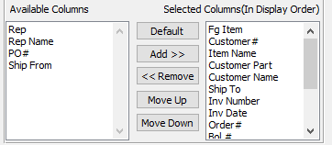

#### Available Columns

The user may choose which columns they wish to have on the report printout. As the user selects their choices, they will appear on the ‘*Selected Columns’* list.

#### Selected Columns (In Display Order)

The columns that the user has chosen from the ‘*Available Columns’* list. The order that these columns are displayed in here is the order in which they will print on the report.

#### Default

Click the ***“Default****”* button to sort the ‘*Selected Columns’* list by the default system parameters.

#### Add >>

Click on the selected item from the ‘*Available Columns’* list to highlight it, then click the ***“Add”*** button to add the selected column to the ‘*Selected Columns’* list.

#### << Remove

Click on the selected item from the ‘*Selected Columns’* list to highlight it, then click the ***“Remove”*** button to remove the selected column to the ‘*Selected Columns’* list.

#### Move Up

Within the ‘*Selected Columns’* list, the user may choose the order they wish the selected columns to print in. In order to change the order of the columns, the user can click on a selection to highlight it. By then clicking the ***“Move Up***” button, the user can change its position on the report.

#### Move Down

Within the ‘*Selected Columns’* list, the user may choose the order they wish the selected columns to print in. In order to change the order of the columns, the user can click on a selection to highlight it. By then clicking the ***“Move Down***” button, the user can change its position on the report.

### Output Destination

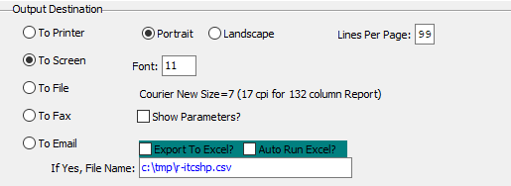

#### Destination Choice

To choose the destination where the document should be printed, please make sure that desired output destination choice bubble is toggled.

#### Layout Choice

To choose the preferred layout of Landscape vs. Portrait, please make sure the desired option choice bubbled is toggled.

#### Lines Per Page

Lines per page on the report when printing.

#### Font

Enter the font number to use with this report (Font 11 is default).

#### Show Parameters? – Toggle Box

To show parameters, make sure that the toggle box is ‘ticked’ with a checkmark.

#### Export to Excel? – Toggle Box

To export the printed file to an excel document, make sure that the Export to Excel toggle box is checked.

#### Auto Run Excel? – Toggle Box

To automatically open the new excel document, make sure that the Auto Run Excel toggle box is checked.

#### If Yes, File Name

If exporting the file to Excel, enter the desired file name.

## Shipments by Item / Customer [HR6]

### Selection Parameters

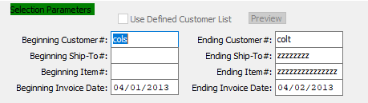

#### Use Defined Customer List – Toggle Box

To use a pre-defined customer list, make sure that this toggle box is checked.

#### Beginning Customer # / Ending Customer #

Enter the beginning and ending Customer Number to run the Shipments report for.

#### Beginning Ship-To # / Ending Ship-To #

Enter the beginning and ending Ship-To Number to run the Shipments report for.

#### Beginning Item # / Ending Item #

Enter the beginning and ending Item Number to run the Shipments report for.

#### Beginning Invoice Date / Ending Invoice Date

Enter the beginning and ending Invoice Date to run the Shipments report for.

### Available and Selected Columns

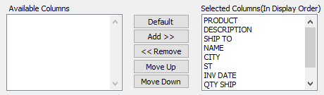

#### Available Columns

The user may choose which columns they wish to have on the report printout. As the user selects their choices, they will appear on the ‘*Selected Columns’* list.

#### Selected Columns (In Display Order)

The columns that the user has chosen from the ‘*Available Columns’* list. The order that these columns are displayed in here is the order in which they will print on the report.

#### Default

Click the ***“Default****”* button to sort the ‘*Selected Columns’* list by the default system parameters.

#### Add >>

Click on the selected item from the ‘*Available Columns’* list to highlight it, then click the ***“Add”*** button to add the selected column to the ‘*Selected Columns’* list.

#### << Remove

Click on the selected item from the ‘*Selected Columns’* list to highlight it, then click the ***“Remove”*** button to remove the selected column to the ‘*Selected Columns’* list.

#### Move Up

Within the ‘*Selected Columns’* list, the user may choose the order they wish the selected columns to print in. In order to change the order of the columns, the user can click on a selection to highlight it. By then clicking the ***“Move Up***” button, the user can change its position on the report.

#### Move Down

Within the ‘*Selected Columns’* list, the user may choose the order they wish the selected columns to print in. In order to change the order of the columns, the user can click on a selection to highlight it. By then clicking the ***“Move Down***” button, the user can change its position on the report.

### Output Destination

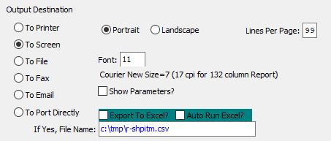

#### Destination Choice

To choose the destination where the document should be printed, please make sure that desired output destination choice bubble is toggled.

#### Layout Choice

To choose the preferred layout of Landscape vs. Portrait, please make sure the desired option choice bubbled is toggled.

#### Show Parameters? – Toggle Box

To show parameters, make sure that the toggle box is ‘ticked’ with a checkmark.

#### Export to Excel? – Toggle Box

To export the printed file to an excel document, make sure that the Export to Excel toggle box is checked.

#### Auto Run Excel? – Toggle Box

To automatically open the new excel document, make sure that the Auto Run Excel toggle box is checked.

#### If Yes, File Name

If exporting the file to Excel, enter the desired file name.

## Sales by Shipping Carrier [HR7]

### Selection Parameters

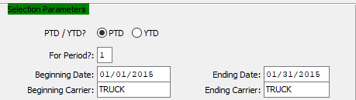

#### To-Date (Choice)

To choose the preferred sales period numbers of Period-to-Date vs. Year-to-Date, please make sure the desired option choice bubble is toggled.

#### For Period?

This is the period number of the transaction date relative to the fiscal year.

#### Beginning Date / Ending Date

Enter the beginning and ending Date to run the Sales by Shipping Carrier report for.

#### Beginning Carrier / Ending Carrier

Enter the beginning and ending Carrier to run the Sales by Shipping Carrier report for.

### Available and Selected Columns

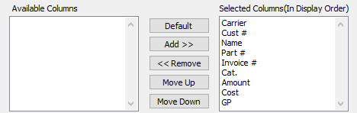

#### Available Columns

The user may choose which columns they wish to have on the report printout. As the user selects their choices, they will appear on the ‘*Selected Columns’* list.

#### Selected Columns (In Display Order)

The columns that the user has chosen from the ‘*Available Columns’* list. The order that these columns are displayed in here is the order in which they will print on the report.

#### Default

Click the ***“Default****”* button to sort the ‘*Selected Columns’* list by the default system parameters.

#### Add >>

Click on the selected item from the ‘*Available Columns’* list to highlight it, then click the ***“Add”*** button to add the selected column to the ‘*Selected Columns’* list.

#### << Remove

Click on the selected item from the ‘*Selected Columns’* list to highlight it, then click the ***“Remove”*** button to remove the selected column to the ‘*Selected Columns’* list.

#### Move Up

Within the ‘*Selected Columns’* list, the user may choose the order they wish the selected columns to print in. In order to change the order of the columns, the user can click on a selection to highlight it. By then clicking the ***“Move Up***” button, the user can change its position on the report.

#### Move Down

Within the ‘*Selected Columns’* list, the user may choose the order they wish the selected columns to print in. In order to change the order of the columns, the user can click on a selection to highlight it. By then clicking the ***“Move Down***” button, the user can change its position on the report.

### Output Destination

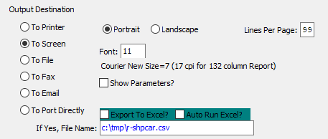

#### Destination Choice

To choose the destination where the document should be printed, please make sure that desired output destination choice bubble is toggled.

#### Layout Choice

To choose the preferred layout of Landscape vs. Portrait, please make sure the desired option choice bubbled is toggled.

#### Lines Per Page

Lines per page on the report when printing.

#### Font

Enter the font number to use with this report (Font 11 is default).

#### Show Parameters? – Toggle Box

To show parameters, make sure that the toggle box is ‘ticked’ with a checkmark.

#### Export to Excel? – Toggle Box

To export the printed file to an excel document, make sure that the Export to Excel toggle box is checked.

#### Auto Run Excel? – Toggle Box

To automatically open the new excel document, make sure that the Auto Run Excel toggle box is checked.

## Sales by Product w/ Cost [HR8]

### Selection Parameters

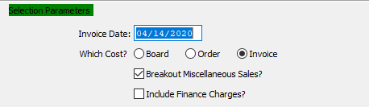

#### Invoice Date

The date the invoice was created which defaults to date in system clock. Format is mm/dd/yy and may be modified.

For releases that are ***"I"*** (Invoice Only), this will default to the date the release was entered. For releases that are ***"S"*** (Ship Only) or ***“B”*** (Both Ship and Invoice), the invoice date will default to the date the Bill of Lading was entered. In any advent, the date may be modified, whereby the aging report will be calculated from the invoice date.

#### Which Cost? (Choice)

To choose the preferred cost selection of Board Cost vs. Order Total vs. Invoice Total, please make sure the desired option choice bubble is toggled.

#### Breakout Miscellaneous Sales? – Toggle Box

To break out miscellaneous sales numbers from other sales figures within the selected parameters, make sure that this toggle box is checked.

#### Include Finance Charges? – Toggle Box

To include and finance charges within the selected parameters on the report, make sure that the Include Finance Charges toggle box is checked.

### Available and Selected Columns

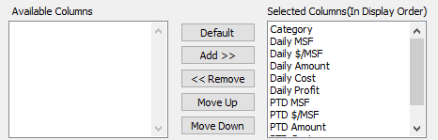

#### Available Columns

The user may choose which columns they wish to have on the report printout. As the user selects their choices, they will appear on the ‘*Selected Columns’* list.

#### Selected Columns (In Display Order)

The columns that the user has chosen from the ‘*Available Columns’* list. The order that these columns are displayed in here is the order in which they will print on the report.

#### Default

Click the ***“Default****”* button to sort the ‘*Selected Columns’* list by the default system parameters.

#### Add >>

Click on the selected item from the ‘*Available Columns’* list to highlight it, then click the ***“Add”*** button to add the selected column to the ‘*Selected Columns’* list.

#### << Remove

Click on the selected item from the ‘*Selected Columns’* list to highlight it, then click the ***“Remove”*** button to remove the selected column to the ‘*Selected Columns’* list.

#### Move Up

Within the ‘*Selected Columns’* list, the user may choose the order they wish the selected columns to print in. In order to change the order of the columns, the user can click on a selection to highlight it. By then clicking the ***“Move Up***” button, the user can change its position on the report.

#### Move Down

Within the ‘*Selected Columns’* list, the user may choose the order they wish the selected columns to print in. In order to change the order of the columns, the user can click on a selection to highlight it. By then clicking the ***“Move Down***” button, the user can change its position on the report.

### Output Destination

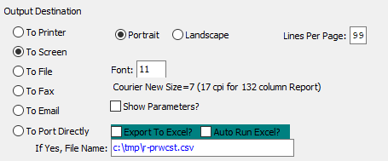

#### Destination Choice

To choose the destination where the document should be printed, please make sure that desired output destination choice bubble is toggled.

#### Layout Choice

To choose the preferred layout of Landscape vs. Portrait, please make sure the desired option choice bubbled is toggled.

#### Show Parameters? – Toggle Box

To show parameters, make sure that the toggle box is ‘ticked’ with a checkmark.

#### Export to Excel? – Toggle Box

To export the printed file to an excel document, make sure that the Export to Excel toggle box is checked.

#### Auto Run Excel? – Toggle Box

To automatically open the new excel document, make sure that the Auto Run Excel toggle box is checked.

#### If Yes, File Name

If exporting the file to Excel, enter the desired file name.

## Sales by Customer Zip Code [HR9]

### Selection Parameters

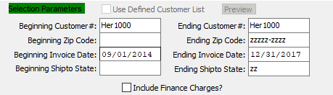

#### Use Defined Customer List – Toggle Box

To use a pre-defined customer list, make sure that this toggle box is checked.

#### Beginning Customer # / Ending Customer #

Enter the beginning and ending Customer Number to run the Sales by Customer Zip Code report for.

#### Beginning Zip Code / Ending Zip Code

Enter the beginning and ending Zip Code to run the Sales by Customer Zip Code report for.

#### Beginning Invoice Date / Ending Invoice Date

Enter the beginning and ending Invoice Date to run the Sales by Customer Zip Code report for.

#### Beginning Ship-To State / Ending Ship-To State

Enter the beginning and ending Ship-To Date to run the Sales by Customer Zip Code report for.

#### Include Finance Charges? – Toggle Box

To include and finance charges within the selected parameters on the report, make sure that the Include Finance Charges toggle box is checked.

### Available and Selected Columns

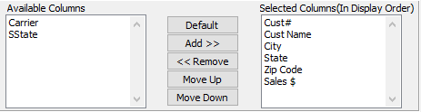

#### Available Columns

The user may choose which columns they wish to have on the report printout. As the user selects their choices, they will appear on the ‘*Selected Columns’* list.

#### Selected Columns (In Display Order)

The columns that the user has chosen from the ‘*Available Columns’* list. The order that these columns are displayed in here is the order in which they will print on the report.

#### Default

Click the ***“Default****”* button to sort the ‘*Selected Columns’* list by the default system parameters.

#### Add >>

Click on the selected item from the ‘*Available Columns’* list to highlight it, then click the ***“Add”*** button to add the selected column to the ‘*Selected Columns’* list.

#### << Remove

Click on the selected item from the ‘*Selected Columns’* list to highlight it, then click the ***“Remove”*** button to remove the selected column to the ‘*Selected Columns’* list.

#### Move Up

Within the ‘*Selected Columns’* list, the user may choose the order they wish the selected columns to print in. In order to change the order of the columns, the user can click on a selection to highlight it. By then clicking the ***“Move Up***” button, the user can change its position on the report.

#### Move Down

Within the ‘*Selected Columns’* list, the user may choose the order they wish the selected columns to print in. In order to change the order of the columns, the user can click on a selection to highlight it. By then clicking the ***“Move Down***” button, the user can change its position on the report.

### Output Destination

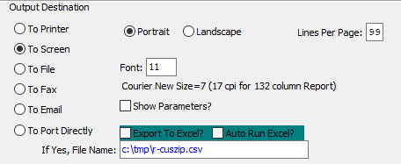

#### Destination Choice

To choose the destination where the document should be printed, please make sure that desired output destination choice bubble is toggled.

#### Layout Choice

To choose the preferred layout of Landscape vs. Portrait, please make sure the desired option choice bubbled is toggled.

#### Show Parameters? – Toggle Box

To show parameters, make sure that the toggle box is ‘ticked’ with a checkmark.

#### Export to Excel? – Toggle Box

To export the printed file to an excel document, make sure that the Export to Excel toggle box is checked.

#### Auto Run Excel? – Toggle Box

To automatically open the new excel document, make sure that the Auto Run Excel toggle box is checked.

#### If Yes, File Name

If exporting the file to Excel, enter the desired file name.

## Sales with Multiple Sorts [HR)]

### Selection Parameters

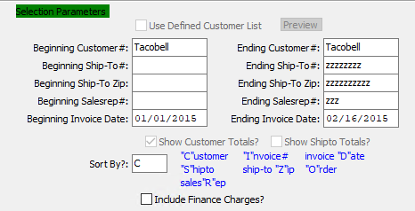

#### Use Defined Customer List – Toggle Box

To use a pre-defined customer list, make sure that this toggle box is checked.

#### Beginning Customer # / Ending Customer #

Enter the beginning and ending Customer Number to run the Sales with Multiple Sorts report for.

#### Beginning Ship-To # / Ending Ship-To #

Enter the beginning and ending Ship-To Number to run the Sales with Multiple Sorts report for.

#### Beginning Ship-To Zip / Ending Ship-To Zip

Enter the beginning and ending Ship-To Zip Code to run the Sales with Multiple Sorts report for.

#### Beginning Sales Rep # / Ending Sales Rep #

Enter the beginning and ending Sales Representative Number to run the Sales with Multiple Sorts report for.

#### Beginning Invoice Date / Ending Invoice Date

Enter the beginning and ending Invoice Date to run the Sales with Multiple Sorts report for.

#### Show Customer Totals? – Toggle Box

To show individual customer totals within the selected parameters, make sure that the Show Customer Totals toggle box is checked.

#### Show Ship-To Totals? – Toggle Box

To show any ship-to totals within the selected parameters, make sure that the Show Ship-To Totals toggle box is checked.

#### Include Finance Charges? – Toggle Box

To include and finance charges within the selected parameters on the report, make sure that the Include Finance Charges toggle box is checked.

#### Sort By? (Choice)

To choose the preferred sorting method, the user may enter their desired choice in this field.

Valid Sorting Options are as Follows:

|  |  |  |  |
| --- | --- | --- | --- |
| C | Customer | R | Sales Representative |
| D | Invoice Date | S | Ship-To |
| I | Invoice Number | Z | Ship-To Zip Code |
| O | Order Number |  |  |

### Available and Selected Columns

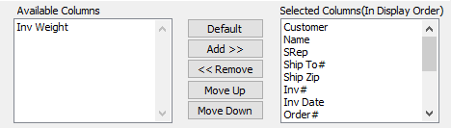

#### Available Columns

The user may choose which columns they wish to have on the report printout. As the user selects their choices, they will appear on the ‘*Selected Columns’* list.

#### Selected Columns (In Display Order)

The columns that the user has chosen from the ‘*Available Columns’* list. The order that these columns are displayed in here is the order in which they will print on the report.

#### Default

Click the ***“Default****”* button to sort the ‘*Selected Columns’* list by the default system parameters.

#### Add >>

Click on the selected item from the ‘*Available Columns’* list to highlight it, then click the ***“Add”*** button to add the selected column to the ‘*Selected Columns’* list.

#### << Remove

Click on the selected item from the ‘*Selected Columns’* list to highlight it, then click the ***“Remove”*** button to remove the selected column to the ‘*Selected Columns’* list.

#### Move Up

Within the ‘*Selected Columns’* list, the user may choose the order they wish the selected columns to print in. In order to change the order of the columns, the user can click on a selection to highlight it. By then clicking the ***“Move Up***” button, the user can change its position on the report.

#### Move Down

Within the ‘*Selected Columns’* list, the user may choose the order they wish the selected columns to print in. In order to change the order of the columns, the user can click on a selection to highlight it. By then clicking the ***“Move Down***” button, the user can change its position on the report.

### Output Destination

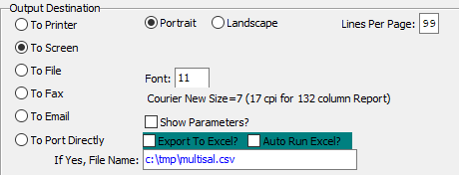

#### Destination Choice

To choose the destination where the document should be printed, please make sure that desired output destination choice bubble is toggled.

#### Layout Choice

To choose the preferred layout of Landscape vs. Portrait, please make sure the desired option choice bubbled is toggled.

#### Lines Per Page

Lines per page on the report when printing.

#### Font

Enter the font number to use with this report (Font 11 is default).

#### Show Parameters? – Toggle Box

To show parameters, make sure that the toggle box is ‘ticked’ with a checkmark.

#### Export to Excel? – Toggle Box

To export the printed file to an excel document, make sure that the Export to Excel toggle box is checked.

#### Auto Run Excel? – Toggle Box

To automatically open the new excel document, make sure that the Auto Run Excel toggle box is checked.

#### If Yes, File Name

If exporting the file to Excel, enter the desired file name.

## Sales by Customer / Item / PO [HR!]

### Selection Parameters

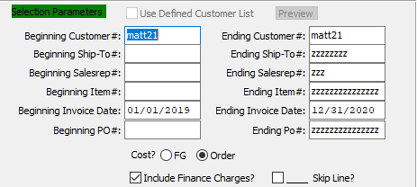

#### Use Defined Customer List – Toggle Box

To use a pre-defined customer list, make sure that this toggle box is checked.

#### Beginning Customer # / Ending Customer #

Enter the beginning and ending Customer Number to run the Sales report for.

#### Beginning Ship-To # / Ending Ship-To #

Enter the beginning and ending Ship-To Number to run the Sales report for.

#### Beginning Sales Rep # / Ending Sales Rep #

Enter the beginning and ending Sales Representative Number to run the Sales report for.

#### Beginning Item # / Ending Item #

Enter the beginning and ending Item Number to run the Sales report for.

#### Beginning Invoice Date / Ending Invoice Date

Enter the beginning and ending Invoice Date to run the Sales report for.

#### Beginning PO # / Ending PO #

Enter the beginning and ending Purchase Order Number to run the Sales report for.

#### Cost? (Choice)

To choose the preferred cost selection for the report of Finished Good (Specific) vs. Other (Any cost other than Finished Good Specific), please make sure the desired option choice bubble is toggled.

#### Include Finance Charges? – Toggle Box

To include and finance charges within the selected parameters on the report, make sure that the Include Finance Charges toggle box is checked.

#### Skip Line? – Toggle Box

To have the printed report skip lines for ease of reading, make sure that the Skip Line toggle box is checked.

### Available and Selected Columns

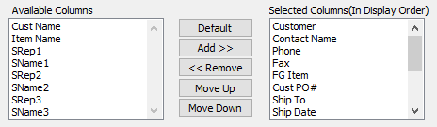

#### Available Columns

The user may choose which columns they wish to have on the report printout. As the user selects their choices, they will appear on the ‘*Selected Columns’* list.

#### Selected Columns (In Display Order)

The columns that the user has chosen from the ‘*Available Columns’* list. The order that these columns are displayed in here is the order in which they will print on the report.

#### Default

Click the ***“Default****”* button to sort the ‘*Selected Columns’* list by the default system parameters.

#### Add >>

Click on the selected item from the ‘*Available Columns’* list to highlight it, then click the ***“Add”*** button to add the selected column to the ‘*Selected Columns’* list.

#### << Remove

Click on the selected item from the ‘*Selected Columns’* list to highlight it, then click the ***“Remove”*** button to remove the selected column to the ‘*Selected Columns’* list.

#### Move Up

Within the ‘*Selected Columns’* list, the user may choose the order they wish the selected columns to print in. In order to change the order of the columns, the user can click on a selection to highlight it. By then clicking the ***“Move Up***” button, the user can change its position on the report.

#### Move Down

Within the ‘*Selected Columns’* list, the user may choose the order they wish the selected columns to print in. In order to change the order of the columns, the user can click on a selection to highlight it. By then clicking the ***“Move Down***” button, the user can change its position on the report.

### Output Destination

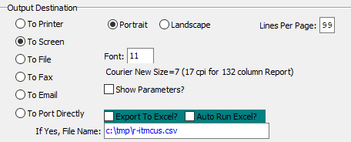

#### Destination Choice

To choose the destination where the document should be printed, please make sure that desired output destination choice bubble is toggled.

#### Layout Choice

To choose the preferred layout of Landscape vs. Portrait, please make sure the desired option choice bubbled is toggled.

#### Lines Per Page

Lines per page on the report when printing.

#### Font

Enter the font number to use with this report (Font 11 is default).

#### Show Parameters? – Toggle Box

To show parameters, make sure that the toggle box is ‘ticked’ with a checkmark.

#### Export to Excel? – Toggle Box

To export the printed file to an excel document, make sure that the Export to Excel toggle box is checked.

#### Auto Run Excel? – Toggle Box

To automatically open the new excel document, make sure that the Auto Run Excel toggle box is checked.

#### If Yes, File Name

If exporting the file to Excel, enter the desired file name.

## Profit w/ Freight [HR@]

### Selection Parameters

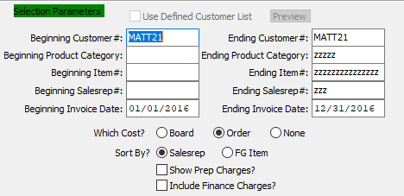

#### Use Defined Customer List – Toggle Box

To use a pre-defined customer list, make sure that this toggle box is checked.

#### Beginning Customer # / Ending Customer #

Enter the beginning and ending Customer Number to run the Profit with Freight report for.

#### Beginning Product Category / Ending Product Category

Enter the beginning and ending Product Category to run the Profit with Freight report for.

#### Beginning Item # / Ending Item #

Enter the beginning and ending Item Number to run the Profit with Freight report for.

#### Beginning Sales Rep # / Ending Sales Rep #

Enter the beginning and ending Sales Representative Number to run the Profit with Freight report for.

#### Beginning Invoice Date / Ending Invoice Date

Enter the beginning and ending Invoice Date to run the Profit with Freight report for.

#### Which Cost? (Choice)

To choose the preferred cost selection for the report of Board vs. Order (Or None), please make sure the desired option choice bubble is toggled.

#### Sort By? (Choice)

To choose the preferred sorting method of Sales Representative vs. Finished Good Item, please make sure the desired option choice bubble is toggled.

#### Show Prep Charges? – Toggle Box

To include any preparation charges attached within the selected parameters, make sure that the Show Prep Charges toggle box is checked.

#### Include Finance Charges? – Toggle Box

To include and finance charges within the selected parameters on the report, make sure that the Include Finance Charges toggle box is checked.

### Available and Selected Columns

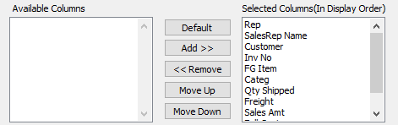

#### Available Columns

The user may choose which columns they wish to have on the report printout. As the user selects their choices, they will appear on the ‘*Selected Columns’* list.

#### Selected Columns (In Display Order)

The columns that the user has chosen from the ‘*Available Columns’* list. The order that these columns are displayed in here is the order in which they will print on the report.

#### Default

Click the ***“Default****”* button to sort the ‘*Selected Columns’* list by the default system parameters.

#### Add >>

Click on the selected item from the ‘*Available Columns’* list to highlight it, then click the ***“Add”*** button to add the selected column to the ‘*Selected Columns’* list.

#### << Remove

Click on the selected item from the ‘*Selected Columns’* list to highlight it, then click the ***“Remove”*** button to remove the selected column to the ‘*Selected Columns’* list.

#### Move Up

Within the ‘*Selected Columns’* list, the user may choose the order they wish the selected columns to print in. In order to change the order of the columns, the user can click on a selection to highlight it. By then clicking the ***“Move Up***” button, the user can change its position on the report.

#### Move Down

Within the ‘*Selected Columns’* list, the user may choose the order they wish the selected columns to print in. In order to change the order of the columns, the user can click on a selection to highlight it. By then clicking the ***“Move Down***” button, the user can change its position on the report.

### Output Destination

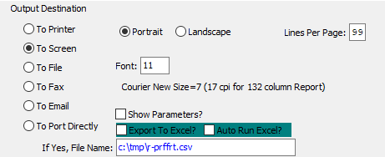

#### Destination Choice

To choose the destination where the document should be printed, please make sure that desired output destination choice bubble is toggled.

#### Layout Choice

To choose the preferred layout of Landscape vs. Portrait, please make sure the desired option choice bubbled is toggled.

#### Lines Per Page

Lines per page on the report when printing.

#### Font

Enter the font number to use with this report (Font 11 is default).

#### Show Parameters? – Toggle Box

To show parameters, make sure that the toggle box is ‘ticked’ with a checkmark.

#### Export to Excel? – Toggle Box

To export the printed file to an excel document, make sure that the Export to Excel toggle box is checked.

#### Auto Run Excel? – Toggle Box

To automatically open the new excel document, make sure that the Auto Run Excel toggle box is checked.

#### If Yes, File Name

If exporting the file to Excel, enter the desired file name.

## Sales by Invoice / Category / Ship-To [HR#]

### Selection Parameters

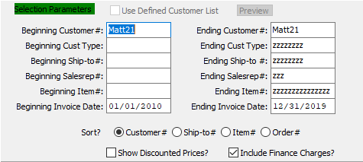

#### Use Defined Customer List – Toggle Box

To use a pre-defined customer list, make sure that this toggle box is checked.

#### Beginning Customer # / Ending Customer #

Enter the beginning and ending Customer Number to run the Sales report for.

#### Beginning Customer Type / Ending Customer Type

Enter the beginning and ending Customer Type to run the Sales report for.

#### Beginning Ship-To # / Ending Ship-To #

Enter the beginning and ending Ship-To Number to run the Sales report for.

#### Beginning Sales Rep # / Ending Sales Rep #

Enter the beginning and ending Sales Representative Number to run the Sales report for.

#### Beginning Item # / Ending Item #

Enter the beginning and ending Item Number to run the Sales report for.

#### Beginning Invoice Date / Ending Invoice Date

Enter the beginning and ending Invoice Date to run the Sales report for.

#### Sort? (Choice)

To choose the preferred sorting method, please make sure the desired option choice bubble is toggled.

#### Show Discounted Prices? – Toggle Box

To show any discounted prices that may exist within the selected parameters, make sure that the Show Discounted Prices toggle box is checked.

#### Include Finance Charges? – Toggle Box

To include and finance charges within the selected parameters on the report, make sure that the Include Finance Charges toggle box is checked.

### Available and Selected Columns

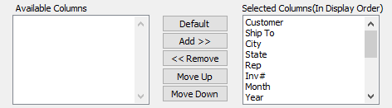

#### Available Columns

The user may choose which columns they wish to have on the report printout. As the user selects their choices, they will appear on the ‘*Selected Columns’* list.

#### Selected Columns (In Display Order)

The columns that the user has chosen from the ‘*Available Columns’* list. The order that these columns are displayed in here is the order in which they will print on the report.

#### Default

Click the ***“Default****”* button to sort the ‘*Selected Columns’* list by the default system parameters.

#### Add >>

Click on the selected item from the ‘*Available Columns’* list to highlight it, then click the ***“Add”*** button to add the selected column to the ‘*Selected Columns’* list.

#### << Remove

Click on the selected item from the ‘*Selected Columns’* list to highlight it, then click the ***“Remove”*** button to remove the selected column to the ‘*Selected Columns’* list.

#### Move Up

Within the ‘*Selected Columns’* list, the user may choose the order they wish the selected columns to print in. In order to change the order of the columns, the user can click on a selection to highlight it. By then clicking the ***“Move Up***” button, the user can change its position on the report.

#### Move Down

Within the ‘*Selected Columns’* list, the user may choose the order they wish the selected columns to print in. In order to change the order of the columns, the user can click on a selection to highlight it. By then clicking the ***“Move Down***” button, the user can change its position on the report.

### Output Destination

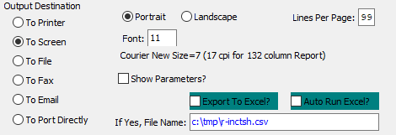

#### Destination Choice

To choose the destination where the document should be printed, please make sure that desired output destination choice bubble is toggled.

#### Layout Choice

To choose the preferred layout of Landscape vs. Portrait, please make sure the desired option choice bubbled is toggled.

#### Lines Per Page

Lines per page on the report when printing.

#### Font

Enter the font number to use with this report (Font 11 is default).

#### Show Parameters? – Toggle Box

To show parameters, make sure that the toggle box is ‘ticked’ with a checkmark.

#### Export to Excel? – Toggle Box

To export the printed file to an excel document, make sure that the Export to Excel toggle box is checked.

#### Auto Run Excel? – Toggle Box

To automatically open the new excel document, make sure that the Auto Run Excel toggle box is checked.

#### If Yes, File Name

If exporting the file to Excel, enter the desired file name.

## High Sales (This Year vs. Last Year) [HR$]

### Selection Parameters

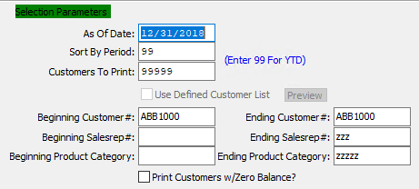

#### As of Date

For Jobs Closed After - (As of) Enter the as of date.

#### Sort By Period

This is the period number of the transaction date relative to the fiscal year.

#### Customers to Print

Enter a selection of customers to print the report for. Each customer should be separated by a comma. Alternatively, leave this field as the default 99999 to use all customers.

#### Use Defined Customer List – Toggle Box

To use a pre-defined customer list, make sure that this toggle box is checked.

#### Beginning Customer # / Ending Customer #

Enter the beginning and ending Customer Number to run the High Sales report for.

#### Beginning Sales Rep # / Ending Sales Rep #

Enter the beginning and ending Sales Representative Number to run the High Sales report for.

#### Beginning Product Category / Ending Product Category

Enter the beginning and ending Product Category to run the High Sales report for.

#### Print Customers w/ Zero Balance? – Toggle Box

To include customers that have a zero balance, make sure that this toggle box is checked.

### Available and Selected Columns

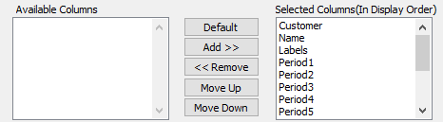

#### Available Columns

The user may choose which columns they wish to have on the report printout. As the user selects their choices, they will appear on the ‘*Selected Columns’* list.

#### Selected Columns (In Display Order)

The columns that the user has chosen from the ‘*Available Columns’* list. The order that these columns are displayed in here is the order in which they will print on the report.

#### Default

Click the ***“Default****”* button to sort the ‘*Selected Columns’* list by the default system parameters.

#### Add >>

Click on the selected item from the ‘*Available Columns’* list to highlight it, then click the ***“Add”*** button to add the selected column to the ‘*Selected Columns’* list.

#### << Remove

Click on the selected item from the ‘*Selected Columns’* list to highlight it, then click the ***“Remove”*** button to remove the selected column to the ‘*Selected Columns’* list.

#### Move Up

Within the ‘*Selected Columns’* list, the user may choose the order they wish the selected columns to print in. In order to change the order of the columns, the user can click on a selection to highlight it. By then clicking the ***“Move Up***” button, the user can change its position on the report.

#### Move Down

Within the ‘*Selected Columns’* list, the user may choose the order they wish the selected columns to print in. In order to change the order of the columns, the user can click on a selection to highlight it. By then clicking the ***“Move Down***” button, the user can change its position on the report.

### Output Destination

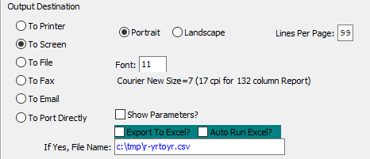

#### Destination Choice

To choose the destination where the document should be printed, please make sure that desired output destination choice bubble is toggled.

#### Layout Choice

To choose the preferred layout of Landscape vs. Portrait, please make sure the desired option choice bubbled is toggled.

#### Lines Per Page

Lines per page on the report when printing.

#### Font

Enter the font number to use with this report (Font 11 is default).

#### Show Parameters? – Toggle Box

To show parameters, make sure that the toggle box is ‘ticked’ with a checkmark.

#### Export to Excel? – Toggle Box

To export the printed file to an excel document, make sure that the Export to Excel toggle box is checked.

#### Auto Run Excel? – Toggle Box

To automatically open the new excel document, make sure that the Auto Run Excel toggle box is checked.

#### If Yes, File Name

If exporting the file to Excel, enter the desired file name.

## Sales by Period [HR%]

### Selection Parameters

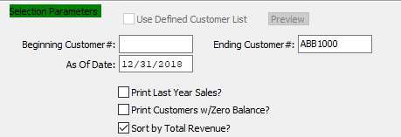

#### Use Defined Customer List – Toggle Box

To use a pre-defined customer list, make sure that this toggle box is checked.

#### Beginning Customer # / Ending Customer #

Enter the beginning and ending Customer Number to run the Sales by Period report for.

#### As of Date

For Jobs Closed After - (As of) Enter the as of date.

#### Print Last Year Sales? – Toggle Box

To print last year’s sales numbers on the report, make sure that the Print Last Year Sales toggle box is checked.

#### Print Customers w/ Zero Balance? – Toggle Box

To include customers that have a zero balance, make sure that this toggle box is checked.

#### Sort by Total Revenue? – Toggle Box

To sort the report by total revenue numbers, make sure that this toggle box is checked.

### Available and Selected Columns

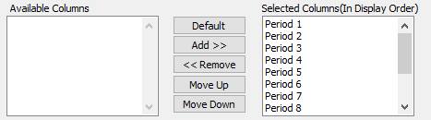

#### Available Columns

The user may choose which columns they wish to have on the report printout. As the user selects their choices, they will appear on the ‘*Selected Columns’* list.

#### Selected Columns (In Display Order)

The columns that the user has chosen from the ‘*Available Columns’* list. The order that these columns are displayed in here is the order in which they will print on the report.

#### Default

Click the ***“Default****”* button to sort the ‘*Selected Columns’* list by the default system parameters.

#### Add >>

Click on the selected item from the ‘*Available Columns’* list to highlight it, then click the ***“Add”*** button to add the selected column to the ‘*Selected Columns’* list.

#### << Remove

Click on the selected item from the ‘*Selected Columns’* list to highlight it, then click the ***“Remove”*** button to remove the selected column to the ‘*Selected Columns’* list.

#### Move Up

Within the ‘*Selected Columns’* list, the user may choose the order they wish the selected columns to print in. In order to change the order of the columns, the user can click on a selection to highlight it. By then clicking the ***“Move Up***” button, the user can change its position on the report.

#### Move Down

Within the ‘*Selected Columns’* list, the user may choose the order they wish the selected columns to print in. In order to change the order of the columns, the user can click on a selection to highlight it. By then clicking the ***“Move Down***” button, the user can change its position on the report.

### Output Destination

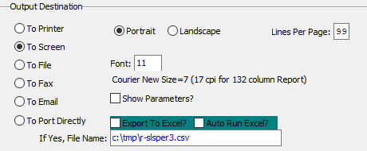

#### Destination Choice

To choose the destination where the document should be printed, please make sure that desired output destination choice bubble is toggled.

#### Layout Choice

To choose the preferred layout of Landscape vs. Portrait, please make sure the desired option choice bubbled is toggled.

#### Show Parameters? – Toggle Box

To show parameters, make sure that the toggle box is ‘ticked’ with a checkmark.

#### Export to Excel? – Toggle Box

To export the printed file to an excel document, make sure that the Export to Excel toggle box is checked.

#### Auto Run Excel? – Toggle Box

To automatically open the new excel document, make sure that the Auto Run Excel toggle box is checked.

#### If Yes, File Name

If exporting the file to Excel, enter the desired file name.

## Sales Comparison by Sales Rep [HR^]

### Selection Parameters

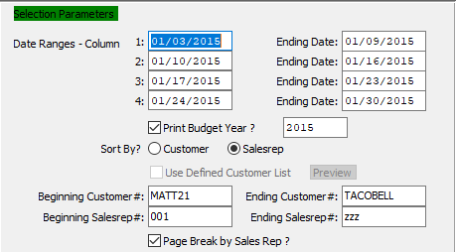

#### Date Ranges: Beginning Date / Ending Date: Columns 1-4

The user may enter up to four separate date ranges to run the report for. Each of these date ranges will print to their own column on the report.

#### Print Budget Year? – Toggle Box

To print the budget year on the report, make sure that the Print Budget Year toggle box is checked.

#### Budget Year

Enter the budget year to run the report for.

#### Sort By? (Choice)

To choose the preferred sorting method of Customer vs. Sales Representative, please make sure the desired option choice bubble is toggled.

#### Use Defined Customer List – Toggle Box

To use a pre-defined customer list, make sure that this toggle box is checked.

#### Beginning Customer # / Ending Customer #

Enter the beginning and ending Customer Number to run the Sales Comparison by Sales Representative report for.

#### Beginning Sales Rep # / Ending Sales Rep #

Enter the beginning and ending Sales Rep # to run the Sales Comparison by Sales Representative report for.

#### Page Break by Sales Rep? – Toggle Box

To break up the report pages by individual sales representatives, make sure that this toggle box is checked.

### Available and Selected Columns

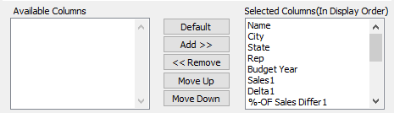

#### Available Columns

The user may choose which columns they wish to have on the report printout. As the user selects their choices, they will appear on the ‘*Selected Columns’* list.

#### Selected Columns (In Display Order)

The columns that the user has chosen from the ‘*Available Columns’* list. The order that these columns are displayed in here is the order in which they will print on the report.

#### Default

Click the ***“Default****”* button to sort the ‘*Selected Columns’* list by the default system parameters.

#### Add >>

Click on the selected item from the ‘*Available Columns’* list to highlight it, then click the ***“Add”*** button to add the selected column to the ‘*Selected Columns’* list.

#### << Remove

Click on the selected item from the ‘*Selected Columns’* list to highlight it, then click the ***“Remove”*** button to remove the selected column to the ‘*Selected Columns’* list.

#### Move Up

Within the ‘*Selected Columns’* list, the user may choose the order they wish the selected columns to print in. In order to change the order of the columns, the user can click on a selection to highlight it. By then clicking the ***“Move Up***” button, the user can change its position on the report.

#### Move Down

Within the ‘*Selected Columns’* list, the user may choose the order they wish the selected columns to print in. In order to change the order of the columns, the user can click on a selection to highlight it. By then clicking the ***“Move Down***” button, the user can change its position on the report.

### Output Destination

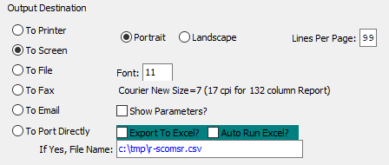

#### Destination Choice

To choose the destination where the document should be printed, please make sure that desired output destination choice bubble is toggled.

#### Layout Choice

To choose the preferred layout of Landscape vs. Portrait, please make sure the desired option choice bubbled is toggled.

#### Lines Per Page

Lines per page on the report when printing.

#### Font

Enter the font number to use with this report (Font 11 is default).

#### Show Parameters? – Toggle Box

To show parameters, make sure that the toggle box is ‘ticked’ with a checkmark.

#### Export to Excel? – Toggle Box

To export the printed file to an excel document, make sure that the Export to Excel toggle box is checked.

#### Auto Run Excel? – Toggle Box

To automatically open the new excel document, make sure that the Auto Run Excel toggle box is checked.

#### If Yes, File Name

If exporting the file to Excel, enter the desired file name.